Chapter 21- SURGERY OF THE THYROID
Edwin L. Kaplan, M.D., Peter Angelos, MD, Ph.D., Raymon H. Grogan, M.D.
Department of Surgery/MC 4052 The University of Chicago 5841 South Maryland Avenue Chicago, IL 60637-1470
Revised 20 December 2012

The extirpation of the thyroid gland…typifies, perhaps better than any operation, the supreme triumph of the surgeon’s art…. A feat which today can be accomplished by any competent operator without danger of mishap and which was conceived more than one thousand years ago…. There are operations today more delicate and perhaps more difficult…. But is there any operative problem propounded so long ago and attacked by so many…which has yielded results as bountiful and so adequate? Dr. William S. Halsted, 1920
Modern thyroid surgery, as we know it today, began in the 1860s in Vienna with the school of Billroth.¹ The mortality associated with thyroidectomy was high, recurrent laryngeal nerve injuries were common, and tetany was thought to be caused by “hysteria.” The parathyroid glands in humans were not discovered until 1880 by Sandstrom, ² and the fact that hypocalcemia was the definitive cause of tetany was not wholly accepted until several decades into the twentieth century. Kocher, ³ a master thyroid surgeon who operated in the late nineteenth and early twentieth centuries in Bern, practiced meticulous surgical technique and greatly reduced the mortality and operative morbidity of thyroidectomy for goiter. He described “cachexia strumipriva” in patients years after thyroidectomy ³ (Fig. 1). Kocher recognized that this dreaded syndrome developed only in patients who had total thyroidectomy. As a result, he stopped performing total resection of the thyroid. We now know, of course, that cachexia strumipriva was surgical hypothyroidism. Kocher received the Nobel Prize for his contributions to thyroid surgery and for this very important contribution, which proved beyond a doubt the physiologic importance of the thyroid gland.
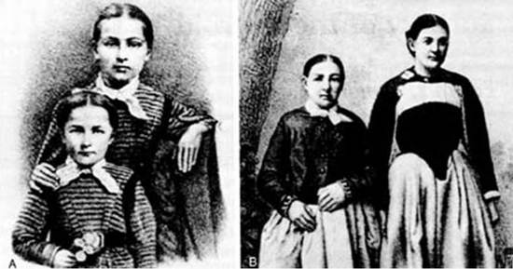
Figure 1. The dramatic case of Maria Richsel, the first patient with postoperative myxedema to have come to Kocher’s attention. A , The child and her younger sister before the operation. B , Changes 9 years after the operation. The younger sister, now fully grown, contrasts vividly with the dwarfed and stunted patient. Also note Maria’s thickened face and fingers, which are typical of myxedema. (From Kocher T: Uber Kropfextirpation und ihre Folgen. Arch Klin Chir 29:254, 1883.)
By 1920, advances in thyroid surgery had reached the point that Halsted referred to this operation as a “feat which today can be accomplished by any competent operator without danger of mishap.” ¹ Unfortunately, decades later, complications still occur. In the best of hands, however, thyroid surgery can be performed today with a mortality that varies little from the risk of general anesthesia alone, as well as with low morbidity. To obtain such enviable results, however, surgeons must have a thorough understanding of the pathophysiology of thyroid disorders; be versed in the preoperative and postoperative care of patients; have a clear knowledge of the anatomy of the neck region; and, finally, use an unhurried, careful, and meticulous operative technique.

IMPORTANT SURGICAL ANATOMY
The thyroid (which means “shield”) gland is composed of two lobes connected by an isthmus that lies on the trachea approximately at the level of the second tracheal ring (Figs. 2 and 3). The gland is enveloped by the deep cervical fascia and is attached firmly to the trachea by the ligament of Berry. Each lobe resides in a bed between the trachea and larynx medially and the carotid sheath and sternocleidomastoid muscles laterally. The strap muscles are anterior to the thyroid lobes, and the parathyroid glands and recurrent laryngeal nerves are associated with the posterior surface of each lobe. A pyramidal lobe is often present. This structure is a long, narrow projection of thyroid tissue extending upward from the isthmus and lying on the surface of the thyroid cartilage. It represents a vestige of the embryonic thyroglossal duct, and it often becomes palpable in cases of thyroiditis or Graves’ disease. The normal thyroid varies in size in different parts of the world, depending on the iodine content in the diet. In the United States it weighs about 15 g.
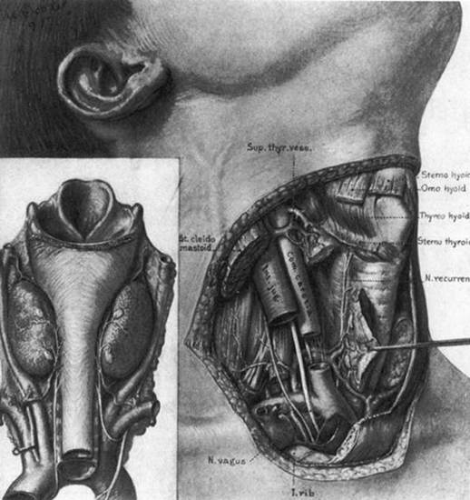
Figure 2. The normal anatomy of the neck in the region of the thyroid gland. (From Halsted WS, The operative story of goiter. Johns Hopkins Hospital Rep 19:71, 1920.)
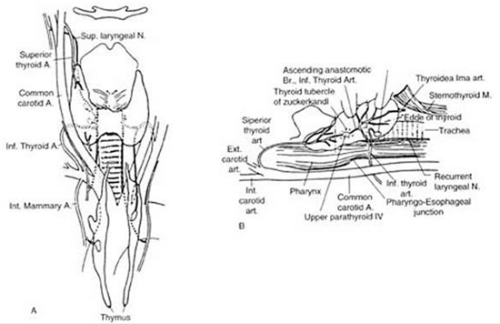
Figure 3. Anatomy of the thyroid and parathyroid glands. A , Anterior view. B , Lateral view with the thyroid retracted anteriorly and medially to show the surgical landmarks (the head of the patient is to the left). (From Kaplan EL: Thyroid and parathyroid. In Schwartz SI [ed: Principles of Surgery, 5th ed. New York, McGraw-Hill, 1989, pp 1613–1685. Copyright © by McGraw-Hill, Inc. Used by permission of McGraw-Hill Book Company.)”]

VASCULAR SUPPLY
The thyroid has an abundant blood supply (Figs. 2 and 3). The arterial supply to each thyroid lobe is twofold. The superior thyroid artery arises from the external carotid artery on each side and descends several centimeters in the neck to reach the upper pole of each thyroid lobe, where it branches. The inferior thyroid artery, each of which arises from the thyrocervical trunk of the subclavian artery, crosses beneath the carotid sheath and enters the lower or midpart of each thyroid lobe. The thyroidea ima is sometimes present; it arises from the arch of the aorta and enters the thyroid in the midline. A venous plexus forms under the thyroid capsule. Each lobe is drained by the superior thyroid vein at the upper pole, which flows into the internal jugular vein; and by the middle thyroid vein at the middle part of the lobe, which enters either the internal jugular or the innominate vein. Arising from each lower pole is the inferior thyroid vein, which drains directly into the innominate vein.

NERVES
The relationship of the thyroid gland to the recurrent laryngeal nerve and to the external branch of the superior laryngeal nerve is of major surgical significance because damage to these nerves leads to disability in phonation and/or to difficulty breathing. ⁴ Both nerves are branches of the vagus nerve.
Injury to the external branch of the superior laryngeal nerve leads to difficulty in singing and projection of the voice. Injury to one recurrent laryngeal nerve may lead to hoarseness of the voice, aspiration, and difficulty breathing. Bilateral recurrent laryngeal nerve injury is much more serious and often leads to the need for a tracheostomy. These injuries will be discussed in greater detail later in this chapter under “Postoperative Complications.”

Recurrent Laryngeal Nerve
The right recurrent laryngeal nerve arises from the vagus nerve, loops posteriorly around the subclavian artery, and ascends behind the right lobe of the thyroid (Fig. 4a). It enters the larynx behind the cricothyroid muscle and the inferior cornu of the thyroid cartilage and innervates all the intrinsic laryngeal muscles except the cricothyroid. The left recurrent laryngeal nerve comes from the left vagus nerve, loops posteriorly around the arch of the aorta, and ascends in the tracheoesophageal groove posterior to the left lobe of the thyroid, where it enters the larynx and innervates the musculature in a similar fashion as the right nerve. Several factors make the recurrent laryngeal nerve vulnerable to injury, especially in the hands of inexperienced surgeons ^{4,6} :
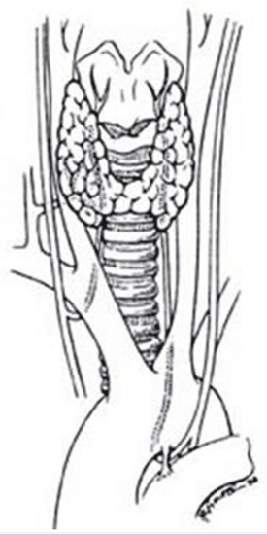
Figure 4a. Anatomy of the recurrent laryngeal nerves. (From Thompson NW, Demers M: Exposure is not necessary to avoid the recurrent laryngeal nerve during thyroid operations. In Simmons RL, Udekwu AO [eds, Debates in Clinical Surgery, Chicago, Year Book Publishers, 1990.)
1. The presence of a nonrecurrent laryngeal nerve (Fig. 4b). Nonrecurrent nerves occur more on the right side (0.6%) than on the left (0.04%). ⁵ They are associated with vascular anomalies such as an aberrant takeoff of the right subclavian artery from the descending aorta (on the right) or a right-sided aortic arch (on the left). In these abnormal positions, each nerve is at greater risk of being divided.
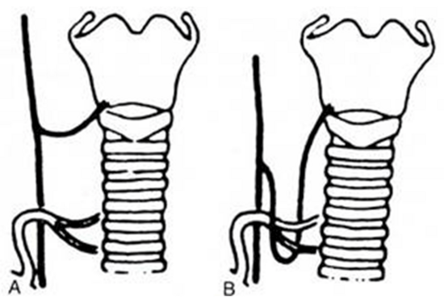
Figure 4b. “Nonrecurrent” right laryngeal nerves coursing ( A ) near the superior pole vessels or ( B ) around the inferior thyroid artery. Because of the abnormal location of “nonrecurrent” nerves, they are much more likely to be damaged during surgery. (From Skandalakis JE, Droulis C, Harlaftis N, et al: The recurrent laryngeal nerve. Am Surg 42:629–634, 1976.)
2. Proximity of the recurrent nerve to the thyroid gland. The recurrent nerve is not always in the tracheoesophageal groove where it is expected to be. It can often be posterior or anterior to this position or may even be surrounded by thyroid parenchyma. Thus, the nerve is vulnerable to injury if it is not visualized and traced up to the larynx during thyroidectomy.
3. Relationship of the recurrent nerve to the inferior thyroid artery. The nerve often passes anterior, posterior, or through the branches of the inferior thyroid artery. Medial traction of the lobe often lifts the nerve anteriorly, thereby making it more vulnerable. Likewise, ligation of the inferior thyroid artery, practiced by many surgeons, may be dangerous if the nerve is not identified first.
4. Deformities from large thyroid nodules. ⁶ In the presence of large nodules the laryngeal nerves may not be in their “correct” anatomic location but may be found even anterior to the thyroid (Fig. 5). Once more, there is no substitute for identification of the nerve in a gentle and careful manner.
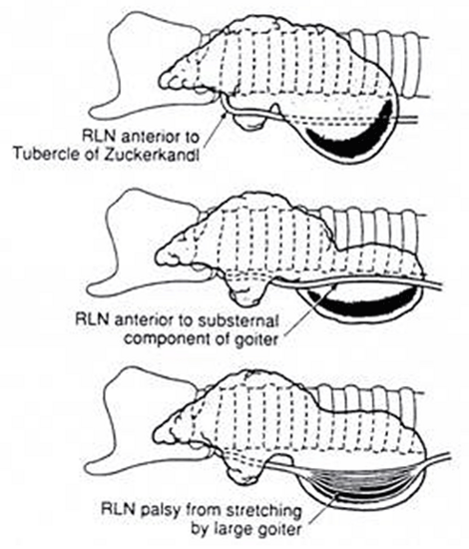
Figure 5. Recurrent laryngeal nerve displacements by cervical and substernal goiters. Such nerves are at risk during lobectomy unless the surgeon anticipates the unusual locations and is very careful. Rarely, the nerves are so stretched by the goiter that spontaneous palsy results. After careful dissection and preservation, functional recovery may occur postoperatively. (From Thompson NW, Demers M: Exposure is not necessary to avoid the recurrent laryngeal nerve during thyroid operations. In Simmons RL, Udekwu AO [eds

External Branch of the Superior Laryngeal Nerve
On each side, the external branch of the superior laryngeal nerve innervates the cricothyroid muscle. In most cases, this nerve lies close to the vascular pedicle of the superior poles of the thyroid lobe, ⁷ which requires that the vessels be ligated with care to avoid injury to it (Fig. 6). In 21%, the nerve is intimately associated with the superior thyroid vessels. In some patients the external branch of the superior laryngeal nerve lies on the anterior surface of the thyroid lobe, making the possibility of damage during thyroidectomy even greater. ⁸ In only 15% of patients is the superior laryngeal nerve sufficiently distant from the superior pole vessels to be protected from manipulation by the surgeon. Unfortunately, many surgeons do not even attempt to identify this nerve before ligation of the upper pole vessels of the thyroid. ^{9, 9a}
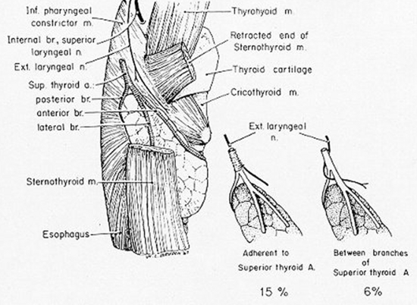
Figure 6. Proximity of the external branch of the superior laryngeal nerve to the superior thyroid vessels. (From Moosman DA, DeWeese MS: The external laryngeal nerve as related to thyroidectomy. Surg Gynecol Obstet 127:1101, 1968.)

PARATHYROID GLANDS
The parathyroids are small glands that secrete parathyroid hormone, the major hormone that controls serum calcium homeostasis in humans. Usually, four glands are present, two on each side, but three to six glands have been found. Each gland normally weighs 30 to 40 mg, but they may be heavier if more fat is present. Because of their small size, their delicate blood supply, and their usual anatomic position adjacent to the thyroid gland, these structures are at risk of being accidentally removed, traumatized, or devascularized during thyroidectomy. ¹⁰
The upper parathyroid glands arise embryologically from the fourth pharyngeal pouch (Figs. 7 and 8). They descend only slightly during embryologic development, and their position in adult life remains quite constant. This gland is usually found adjacent to the posterior surface of the middle part of the thyroid lobe, often just anterior to the recurrent laryngeal nerve as it enters the larynx.
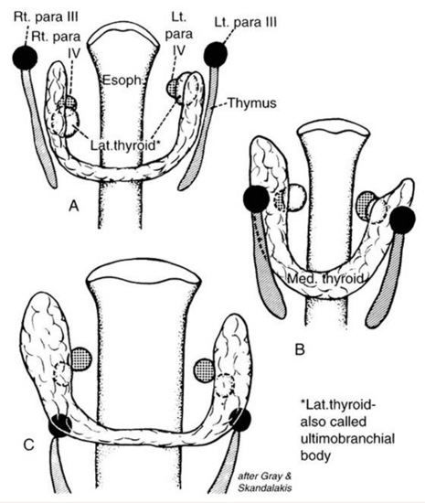
Figure 7. A and B , Shifts in location of the thyroid, parafollicular, and parathyroid tissues. C approximates the adult location. Note that what has been called the lateral thyroid is now commonly referred to as the ultimobranchial body, which contains both C cells and follicular elements. (From Sedgwick CE, Cady B: Surgery of the Thyroid and Parathyroid Gland, 2nd ed. Philadelphia, WB Saunders, 1980; adapted from Norris EH: Parathyroid glands and lateral thyroid in man: Their morphogenesis, histogenesis, topographic anatomy and prenatal growth. Contrib Embryol Carnegie Inst Wash 26:247–294, 1937.)
: Principles of Surgery, 5th ed. New York, McGraw-Hill, 1989, pp 1613–1685. Copyright © by McGraw-Hill, Inc. Used by permission of McGraw-Hill Book Company.)”]
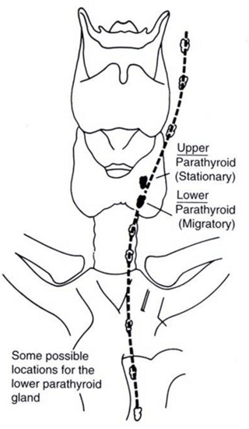
Figure 8. Descent of the lower parathyroid. Whereas the upper parathyroid occupies a relatively constant position in relation to the middle or upper third of the lateral thyroid lobe, the lower parathyroid normally migrates in embryonic life and may end up anywhere along the course of the dotted line. When this gland is in the chest, it is nearly always in the anterior mediastinum. (From Kaplan EL: Thyroid and parathyroid. In Schwartz SI [ed])
The lower parathyroid glands arise from the third pharyngeal pouch, along with the thymus; hence, they often descend with the thymus. Because they travel so far in embryologic life, they have a wide range of distribution in adults, from just beneath the mandible to the anterior mediastinum ¹¹ (see Fig. 8). Usually, however, these glands are found on the lateral or posterior surface of the lower part of the thyroid gland or within several centimeters of the lower thyroid pole within the thymic tongue.
Parathyroid glands can be recognized by their tan appearance; their small vascular pedicle; the fact that they bleed freely when a biopsy is performed, as opposed to fatty tissue; and their darkening color of hematoma formation when they are traumatized. With experience, one becomes much more adept at recognizing these very important structures and in differentiating them from either lymph nodes or fat. Frozen section examination during surgery can be helpful in their identification.

LYMPHATICS
A practical description of the lymphatic drainage of the thyroid gland for the thyroid surgeon has been proposed by Taylor. ¹² The results of his studies, which are clinically very relevant to the lymphatic spread of thyroid carcinoma, are summarized in the following.
Central Compartment of the Neck
1. The most constant site to which dye goes when injected into the thyroid is the trachea, the wall of which contains a rich network of lymphatics. This fact probably accounts for the frequency with which the trachea is involved by thyroid carcinoma, especially when it is anaplastic. This involvement is sometimes the limiting factor in surgical excision.
2. A chain of lymph nodes lies in the groove between the trachea and the esophagus (Level 6, Fig. 8).
3. Lymph can always be shown to drain toward the mediastinum and to the nodes intimately associated with the thymus (Level 7, Fig. 8).
4. One or more nodes lying above the isthmus, and therefore in front of the larynx, are sometimes involved. These nodes have been called the Delphian nodes (named for the oracle of Delphi) because it has been said that if palpable, they are diagnostic of carcinoma. However, this clinical sign is often misleading.
5. A bilateral central lymph node dissection, called a level 6 dissection (See Fig. 8) clears out all these lymph nodes from one carotid artery to the other carotid artery and down into the superior mediastinum as far as possible. ^{12a}
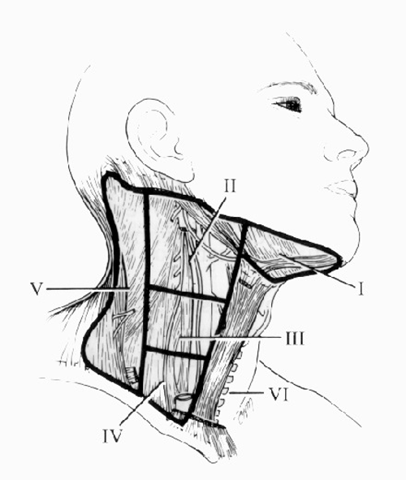
Figure 8. The lymph node regions of the neck are divided into levels I through VII: 1) level I nodes are the submental and submandibular nodes; 2) level II are the upper jugular nodes; 3) level III are the midjugular nodes; 4) level IV are the lower jugular nodes; 5) level V are the posterior triangle and supraclavicular nodes; 6) level VI or central compartment nodes incorporate the Delphian/prelaryngeal, pretracheal, and paratracheal lymph nodes; and 7) level VII nodes are those within the superior mediastinum.

Lateral Compartment of the Neck
A constant group of nodes lies along the jugular vein on each side of the neck (Levels 2, 3, and 4). The lymph glands found in the supraclavicular fossae or more laterally in the neck (Level 5) may also be involved in more extensive spread of malignant disease from the thyroid gland.^{12a} Finally, it should not be forgotten that the thoracic duct on the left side of the neck, a lymph vessel of considerable size, arches up out of the mediastinum and passes forward and laterally to drain into the left subclavian vein or the internal jugular vein near their junction. If the thoracic duct is damaged, the wound is likely to fill with lymph; in such cases, the duct should always be sought and ligated. A wound that discharges lymph postoperatively should always raise suspicion of damage to the thoracic duct or a major tributary. A lateral lymph node dissection encompasses removal of these lateral lymph nodes (Fig. 9a). Rarely, the submental nodes (Level 1) are involved by metastatic thyroid cancer as well.
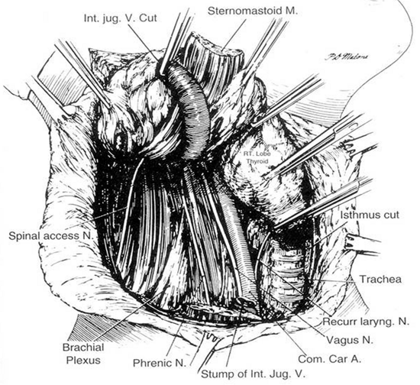
Figure 9a. Lateral neck dissection. Note that during this procedure lymph nodes from Levels 2, 3, 4, and 5 are removed. The vagus nerve, sympathetic ganglia, phrenic nerve, brachial plexus, and spinal accessory nerve are preserved. In a modified neck dissection the sternocleidomastoid muscle is not usually divided, and the jugular vein is not removed unless lymph nodes with tumor are adherent to it. (From Sedgwick CE, Cady B: In Surgery of the Thyroid and Parathyroid Glands. Philadelphia, WB Saunders, 1980, p 180.)

INDICATIONS FOR THYROIDECTOMY
Thyroidectomy is usually performed for the following reasons:
1. As therapy for some individuals with thyrotoxicosis, both those with Graves’ disease and others with hot nodules
2. To establish a definitive diagnosis of a mass within the thyroid gland, especially when cytologic analysis after fine-needle aspiration (FNA) is either nondiagnostic, equivocal, or indeterminate
3. To treat benign and malignant thyroid tumors
4. To alleviate pressure symptoms or respiratory difficulties associated with a benign or malignant process
5. To remove an unsightly goiter (Figs. 9b and 9c)
6. To remove large substernal goiters, especially when they cause respiratory difficulties
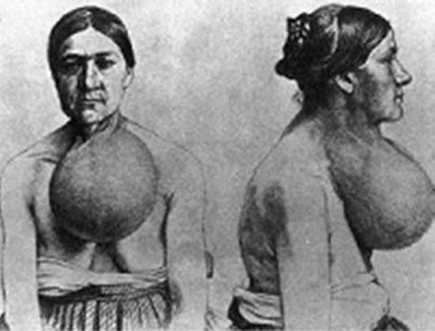
Figure 9b. Large goiters are prevalent in areas of iodine deficiency. A woman from Switzerland operated upon by Dr. Theodor Kocher (From Kocher (3).
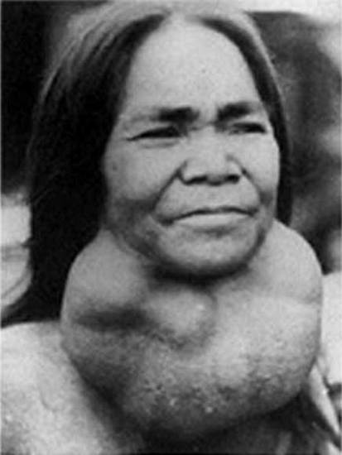
Figure 9c. Large goiters are prevalent in areas of iodine deficiency. Many decades later, large goiters still occur in many parts of the world, as demonstrated in this woman from a mountainous region of Vietnam, 1970.

SOLITARY THYROID NODULES
Solitary thyroid nodules are found in 4% to 9% of patients by clinical examination, and in 22% or more of patients by ultrasound in the United States; most are benign. ¹³ Therefore, rather than operating on every patient with a thyroid nodule, the physician or surgeon should select patients for surgery who are at high risk for thyroid cancer. Furthermore, each surgeon must know the complications of thyroidectomy and either be able to perform a proper operation for thyroid cancer in a safe and effective manner or refer the patient to a center where it can be done.

LOW-DOSE EXTERNAL IRRADIATION OF THE HEAD AND NECK
A history of low-dose external irradiation of the head or neck (less than 1500 rads) is probably the most important historical fact that can be obtained in a patient with a thyroid nodule because it indicates that cancer of the thyroid , usually papillary cancer, is more likely (in up to 35% of cases), even if the gland is multinodular. ^{14,15} Low-dose irradiation and its implications are discussed elsewhere. ^{15a} Fortunately, treatments of low-dose radiation for benign conditions--thymic enlargement, tonsils, and acne-- have long been discontinued. However, patients who had this therapy in infancy or childhood are still seen and are still at a greater risk of cancer.^{15b}

HIGH-DOSE EXTERNAL IRRADIATION THERAPY
High-dose external irradiation therapy, that is, more than 2000 rad, does not confer safety from thyroid carcinoma, as was previously thought.¹⁶Rather, an increased prevalence of thyroid carcinoma, usually papillary cancer, has been found, particularly in patients with Hodgkin’s disease and other lymphomas who received upper mantle irradiation that included the thyroid gland.^{15b} Usually, a dose of about 4000 to 5000 rad was given. Both benign and malignant thyroid nodules have been recognized, now that these persons survive for longer periods.¹⁷ If a thyroid mass appears, it should be treated aggressively. These patients should also be observed carefully for the development of hypothyroidism.

RISK OF IONIZING RADIATION
Children exposed to ionizing radiation in the area of the Chernobyl nuclear accident have been shown to have at least a 30-fold increase in papillary thyroid cancer.¹⁸ This cancer may also be more aggressive than the usual papillary carcinoma and demonstrated more local invasion and lymph node metastases. It is thought to be the result of exposure to iodine isotopes that were inhaled or that entered the food chain. The mechanism of radiation-induced thyroid cancer is thought to be caused primarily by chromosomal rearrangements such as RET/PTC ¹⁹ and less commonly to BRAF mutations. ^{19a, 19b}

DIAGNOSIS OF THYROID NODULES
Diagnostic modalities such as nuclear scans had been used widely in the past, but currently they have been superseded by a fine needle aspiration (FNA) of the mass with cytologic analysis (Fig. 10). In the hands of a good thyroid cytologist, more than 90% of nodules can be categorized histologically. Approximately 60% to 70% are found to be compatible with a colloid (benign) nodule. Fifteen to 30% demonstrate sheets of follicular cells with little or no colloid (an indeterminate lesion). Indeterminate lesions can be further classified as a follicular lesion of undetermined significance (FLUS) or as a possible follicular neoplasm (Table 1). Five to 10% of FNA’s are malignant, and less than 10% are nondiagnostic. In order to improve the diagnostic ability of FNA, researchers are adding biomarkers to the cytologic analyses. ^{20,21} A new system for reporting thyroid cytopathology with the potential risk of malignancy, called the Bethesda system, is shown in Table 1. ^{21a}
TABLE 1. Implied Risk of Malignancy and Recommended Clinical Management
Diagnostic category | Risk of malignancy (%) | Usual management
Nondiagnostic or unsatisfactory | 1-4 | Repeat FNA with ultrasound guidance
Benign | 0-3 | Clinical follow-up
Atypia of undetermined significance or follicular lesion of undetermined significance | ∼5-15 | Repeat FNA (or operate)
Follicular neoplasm or suspicious for a follicular neoplasm | 15-30 | Surgical lobectomy
Suspicious for malignancy | 60-75 | Near-total thyroidectomy or surgical lobectomy ^{c}
Malignant | 97-99 | Near-total or total thyroidectomy
Adapted from: Cibas ES and Ali SZ: The Bethesda System for Reporting Thyroid Cytology. Thyroid 19:1159-1165, 2009.
As shown in Table 1, all patients who have malignant cytologic results should be operated upon. False positive results are rare. Patients with the cytologic diagnosis of a follicular neoplasm or suspicion of a follicular neoplasm should also be operated upon for up to 30% of these tumors prove to be carcinoma. When atypia of undetermined significance or a follicular lesion of undetermined significance (FLUS) is reported, some clinicians recommend a repeat FNA several months later (Table 1). However, others recommend operation, since up to 15% of these FLUS lesions also prove at operation to be malignant. In some recent studies of follicular lesions, experiments are being conducted to determine whether the use of molecular markers such as BRAF, RAS, RET/PTC, PAX8-PPAR, or Galectin 3 will aid in differentiating benign from malignant lesions.^{21a} In another recent study of 265 indeterminate nodules, classified by FNA and then operated upon, 85 (32%) proved to be carcinomas. Using a diagnostic test that measures the expression of 167 genes, investigators were able to identify 78 of the 85 carcinomas as suspicious and to recognize most of the other lesions as benign.^{21b} Thus, in the future, perhaps these or similar tests will become routine and will reduce the number of operations currently performed for these indeterminate lesions which are ultimately found to be benign.
When the diagnosis of colloid nodule is made cytologically, the patient should be observed and not operated on unless tracheal compression or a substernal goiter is present, or unless the patient desires the benign mass to be removed. Finally, if an inadequate specimen is obtained, FNA with cytologic examination should be repeated. Usually one waits several months between needle biopsies.
With small, nonpalpable masses, FNA should be performed under ultrasound guidance. Thus, FNA with cytologic assessment is the most powerful tool in our armamentarium for the diagnosis of a thyroid nodule.
In summary, the algorithm for the diagnosis of a thyroid nodule with isotope scintigraphy and ultrasonography as initial steps has been replaced in most hospitals, including our own, by emphasizing the importance of early cytologic examination using fine needle aspirate (FNA) (Fig. 10). Far fewer isotope scans are currently being done because carcinomas represent only 5% to 10% of all cold nodules. This test is usually reserved for diagnosis of a “hot” nodule.

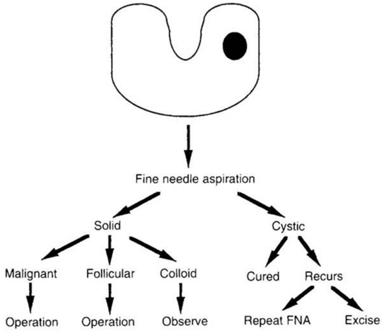
Figure 10. Algorithm for the diagnosis of a thyroid nodule with fine-needle aspiration (FNA) and cytologic examination of each nodule. Greater accuracy is obtained by using this diagnosis scheme. (Courtesy of Dr. Jon van Heerden.)

PREPARATION FOR SURGERY
Most patients undergoing a thyroid operation are euthyroid and require no specific preoperative preparation related to their thyroid gland. Determination of serum calcium and parathyroid hormone (PTH) levels may be helpful, and endoscopic or indirect laryngoscopy should definitely be performed in those who are hoarse and in others who have had a prior thyroid, parathyroid, or cervical disc operation in order to detect the possibility of a recurrent laryngeal nerve injury.

HYPOTHYROIDISM
Modest hypothyroidism is of little concern when treating a surgical patient; however, severe hypothyroidism can be a significant risk factor. Severe hypothyroidism can be diagnosed clinically by myxedema, as well as by slowness of affect, speech, and reflexes. ²² Circulating thyroxine and triiodothyronine values are low. The serum thyroid-stimulating hormone (TSH) level is high in all cases of hypothyroidism that are not caused by pituitary insufficiency, and it is the best test of thyroid function. In the presence of severe hypothyroidism, both the morbidity and the mortality of surgery are increased as a result of the effects of both the anesthesia and the operation. Such patients have a higher incidence of perioperative hypotension, cardiovascular problems, gastrointestinal hypomotility, prolonged anesthetic recovery, and neuropsychiatric disturbances. They metabolize drugs slowly and are very sensitive to all medications. Therefore, when severe myxedema is present, it is preferable to defer elective surgery until a euthyroid state is achieved.
If urgent surgery is necessary, it should not be postponed simply for repletion of thyroid hormone. Endocrine consultation is imperative, and an excellent anesthesiologist is mandatory for success. In most cases, intravenous thyroxine can be started preoperatively and continued thereafter. In general, small doses of thyroxine are initially given to patients who are severely hypothyroid, and then the dose is gradually increased.

HYPERTHYROIDISM
In the United States, most patients with thyrotoxicosis have Graves’ disease. Furthermore, in the United States, about 90% of all patients with Graves’ disease are treated with radioiodine therapy. Young patients, those with very large goiters, some pregnant women, and those with thyroid nodules or severe ophthalmopathy are commonly operated upon.
Persons with Graves’ disease or other thyrotoxic states should be treated preoperatively to restore a euthyroid state and to prevent thyroid storm, a severe accentuation of the symptoms and signs of hyperthyroidism that can occur during or after surgery. Thyroid storm results in severe tachycardia or cardiac arrhythmias, fever, disorientation, coma, and even death. In the early days of thyroid surgery, operations on the toxic gland were among the most dangerous surgical procedures because of the common occurrence of severe bleeding, as well as all the symptoms and signs of thyroid storm. Now, with proper preoperative preparation, ²³ operations on the thyroid gland in Graves’ disease can be performed with about the same degree of safety as operations for other thyroid conditions.
In mild cases of Graves’ disease with thyrotoxicosis, iodine therapy alone has been used for preoperative preparation, although we do not recommend this approach routinely. ²² Lugol’s solution or a saturated solution of potassium iodide is given for 8 to 10 days. Although only several drops per day are needed to block the release of thyroxine from the toxic thyroid gland, it is our practice to administer two drops two or three times daily. This medication is taken in milk or orange juice to make it more palatable. Iodine therapy suppresses thyroid hormone release only in Graves’ disease and should not be given to patients with toxic nodular goiter.
Most of our patients with Graves’ disease are treated initially with the antithyroid drugs propylthiouracil (PTU) or methimazole (Tapazole) until they approach a euthyroid state. Then iodine is added to the regimen for 8 to 10 days before surgery. The iodine decreases the vascularity and increases the firmness of the gland. Sometimes thyroxine is added to this regimen to prevent hypothyroidism and to decrease the size of the gland. Beta-adrenergic blockers such as propranolol (Inderal) have increased the safety of thyroidectomy for patients with Graves’ disease. ²³ We use them commonly with antithyroid drugs to block alpha-adrenergic receptors, and ameliorate the major signs of Graves’ disease by decreasing the patient’s pulse rate and eliminating the tremor. Some surgeons recommend preoperative use of propranolol alone or with iodine. ²⁴ These regimens, they believe, shorten the preparation time of patients with Graves’ disease for surgery and make the operation easier because the thyroid gland is smaller and less friable than it would otherwise be. ²⁴ We do not favor these regimens for routine preparation because they do not appear to offer the same degree of safety as do preoperative programs that restore a euthyroid state before surgery. Instances of fever and tachycardia have been reported in persons with Graves’ disease who were taking only propranolol. We have used propranolol therapy alone or with iodine without difficulty in some patients who are allergic to antithyroid medications. In such patients it is essential to continue the propranolol for several weeks postoperatively. Remember that they are still in a thyrotoxic state immediately after surgery, although the peripheral manifestations of their disease have been blocked.
The major advantages and disadvantages of radioiodine vs. thyroidectomy as definitive treatment of Graves’ disease are listed in Table 2. In our patients we have never had a death from thyroidectomy for Graves’ disease in over 40 years. Surgical resection involves subtotal, near total thyroidectomy (Fig. 11), or lobectomy with contralateral subtotal or near total lobectomy (Dunhill procedure). Previously we left 2 to 2.5 grams of thyroid in the neck. However, this resulted in a recurrence rate of approximately 12% at about 10 year followup. ²⁵ Hence, currently we leave very small thyroid remnants and treat the patients with thyroxine replacement. Especially in children and adolescents, one should consider a total thyroidectomy or leaving a very small amount of tissue because the incidence of recurrence of thyrotoxicosis appears to be greater in this young group. Finally, when operating for severe ophthalmopathy, we try to perform near-total or total thyroidectomy, for improvement in the eyes may occur after this procedure. Of course, when operating on the thyroid, and especially in young patients with a benign condition, the surgeon should be very careful to avoid permanent hypoparathyroidism and nerve injury. These complications will be discussed later in this chapter.
The major benefits of thyroidectomy appear to be the removal of nodules if they are present, the speed with which normalization of thyroid function is achieved, possible improvement in the eyes, and possibly a lower rate of hypothyroidism than is seen after radioiodine therapy.
Basic Surgery, 4th ed. St. Louis, Quality Medical Publishing, 1993, pp 162–195.)”]
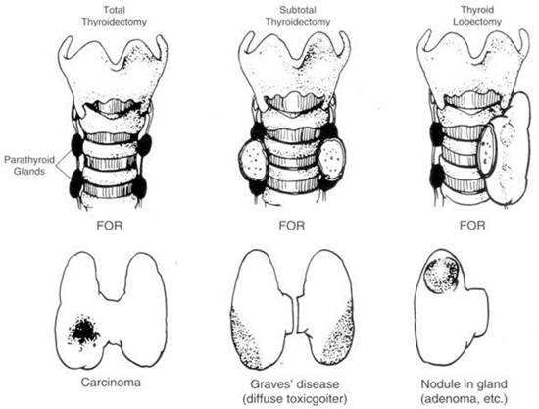
Figure 11. Common operations on the thyroid. In near-total thyroidectomy, a small amount of thyroid tissue is left to protect the recurrent laryngeal nerve and upper parathyroid gland. (From Kaplan EL: Surgical endocrinology. In Polk HC, Stone HH, Gardner B [eds
TABLE 2. Ablative Treatment of Graves’ Disease With Thyrotoxicosis
Method | Dose or Extent of Surgery | Onset of Response | Complications | Remarks
Surgery | Subtotal excision of gland (leaving about 1-2 g remnant or less) | Immediate | Mortality: <1%  Permanent hypothyroidism: 20-30% or greater  Recurrent hyperthyroidism: <15%  Vocal cord paralysis: ≈ 1%  Hypoparathyroidism: ≈ 1% | Applicable in young patients and pregnant women
Radioiodine | 5-10 mCi | Several weeks to months | Permanent hypothyroidism: 50%-70%, often with delayed onset; multiple treatments sometimes necessary; recurrence possible | Avoid in children or pregnant women

SURGICAL APPROACH TO THYROID NODULES

Colloid Nodule(s)
If a colloid nodule is diagnosed on FNA, there is no urgency to operate in most cases. Patients often are rebiopsied in the future to reduce the chance of error and are followed in 6 to 12 months with repeat ultrasound. Respiratory compromise, substernal goiter, rapid growth, and pain are reasons for operation. Some patients desire a thyroidectomy to get over the problem or for an unsightly mass. Thyroid lobectomy, subtotal thyroidectomy, or near total or total thyroidectomy can be done and each approach has advocates.
A “toxic nodule” can occur and can be cured by enucleation since it is rarely a carcinoma and since normal thyroid function might follow this approach. Otherwise, a thyroid resection is preferable.
Follicular (indeterminate) Nodules
The surgical treatment of a nodule which is diagnosed on FNA as either a follicular lesion of undetermined significance (FLUS) or a follicular neoplasm is more controversial. The problem is that the pathologist rarely can tell which are benign and which are malignant on frozen section. They cannot tell which are follicular adenomas and which are follicular carcinomas, for example, at the time of operation. This usually requires careful evaluation of many sections for capsular invasion or vascular invasion on permanent sections. Of course, at operation, lymph nodes can be biopsied, but in most small masses of this type they are negative.
These difficulties should be discussed with the patient preoperatively and usually he or she will guide the surgeon. For there are two operative courses: a lobectomy or a near-total or total thyroidectomy. The American Thyroid Association guidelines recommend a thyroid lobectomy in such instances and to await the final diagnosis.^{21a} This is the choice of most patients.
However, if the lesion turns out to be a carcinoma on permanent pathologic analysis, a second operation is necessary, with a second anesthesia, etc., and may be more difficult because of adhesions. Furthermore, many patients require thyroid hormone replacement therapy after only a thyroid lobectomy. Thus, some patients choose to have a near-total or total thyroidectomy at the first operation, especially if they have bilateral nodules. But the wise surgeon will have this discussion preoperatively and do what the patient wants, since there is no correct answer.

Irradiated Patients
Patients who received low-dose or high-dose external irradiation or were exposed to excessive ionizing radiation are at risk of developing single or multiple nodules of the thyroid, both benign and malignant.^{15b} There is a greater chance of malignancy than in the non-irradiated gland. For single nodules, FNA analysis is performed and the decision as to whether or not to operate is determined by the result of the cytology. Multiple nodules in such a patient present more of a diagnostic problem.
When an operation is performed in a patient with a radiation history and a suspicious nodule, we are more inclined to perform a near-total or total thyroidectomy rather than a lobectomy. This procedure removes all of the nodules and also removes all potentially damaged thyroid tissue.

SURGICAL APPROACH TO THYROID CANCER

PAPILLARY CARCINOMA
It is estimated that 56,460 new cases of thyroid cancer will be diagnosed in 2012, with 3 of 4 cases occurring in women.^{26c} Thyroid cancer is the fastest increasing cancer in both men and women. Since 2004, incidence rates have been rising 6.6% per year in women and 5.5% per year in men. An estimated 1780 deaths from thyroid cancer are expected in 2012. The death rates of women and men have increased slightly from 2004 to 2008 as well.
Approximately 80 to 85% of all thyroid cancers are papillary cancer. The surgical treatment of papillary cancer is best divided into two groups based on the size, clinical characteristics, and aggressiveness of these lesions.

Treatment of Minimal Papillary Carcinoma
The term minimal papillary carcinoma refers to a small papillary cancer, less than 1 cm in diameter, that demonstrates no local invasiveness through the thyroid capsule, that is not associated with lymph node metastases, and that is often found in a young person as an occult lesion when thyroidectomy has been performed for another benign condition. In such instances, especially when the cancer is unicentric and smaller than 5 mm, lobectomy is sufficient and reoperations are unnecessary. Thyroid hormone is given to suppress serum TSH levels, and the patient is monitored at regular intervals.^{21a}

Standard Treatment of Most Papillary Carcinomas
Most papillary carcinomas are neither minimal nor occult. These tumors are known to be microscopically multicentric in up to 80% of patients; they are also known occasionally to invade locally into the trachea or esophagus, to metastasize commonly to lymph nodes and later to the lungs and other tissues, and to recur clinically in the other thyroid lobe in 7% to 18% of patients if treated only by thyroid lobectomy. ^{26a, 26b}
The authors firmly believe that the best treatment of papillary cancer is near-total or total thyroidectomy (see Fig. 11), with appropriate central and lateral neck dissection when nodes are involved. The so-called cherry-picking operations, which remove only the enlarged lymph nodes, should not be performed. Rather, when lymph nodes with tumor are found in the lateral triangle, a modified radical neck dissection should be performed ²⁷ (Fig. 9a). At the conclusion of a modified radical neck dissection, the lymph node–bearing tissue from the lateral neck is removed, whereas the carotid artery, jugular vein, phrenic nerve, sympathetic ganglia, brachial plexus, and spinal accessory nerve are spared and left in place. Sensory nerves,the posterior occipital, and greater auricular nerves should be retained as well. On the left side, care should be exercised not to injure the thoracic duct. Prophylactic neck dissection of the lateral triangle should not be performed for papillary cancer; such dissections should be done only when enlarged nodes with tumor are found.
In recent years, for clarity and uniformity of reporting, the location of lymph nodes in the neck and upper mediastinum has been defined as shown in Fig. 8. Central lymph nodes (level VI) are frequently involved with metastases from ipsilateral thyroid cancers, as are levels III, IV, and V which are removed in most lateral neck dissections. Level II nodes may be involved as well and often require removal.
Should Prophylactic Central (Level 6) Lymph Node Dissections be Performed?
There is agreement that therapeutic central and lateral lymph node dissections should be performed at the time of total thyroidectomy when lymph nodes are suspicious or proved to harbor cancer by sonographic appearance or by FNA analyses preoperatively or when suspicious lymph nodes are found at operation. Prophylactic lateral lymph node dissections were common in the past, but have been abandoned for several decades or longer. ^{12a}
Recently, Delbridge and his group and others have proposed that unilateral or bilateral prophylactic central lymph node dissections (level 6 dissections) with parathyroid autotransplantation be performed in all cases of papillary thyroid cancer at the time of total thyroidectomy. ^{12a, 27a} This, they state, might decrease mortality from thyroid cancer, would greatly decrease recurrence of cancer, and would further clarify who needs radioiodine therapy postoperatively. Some studies by very experienced surgeons demonstrate no increase in hypoparathyroidism or recurrent laryngeal nerve injuries after this procedure, while other equally competent surgeons have found an increase in permanent hypoparathyroidism. ^{27b, 27c}
We and others do not routinely perform this procedure because of the increased risk of hypoparathyroidism, but reserve it for cases in which ipsilateral central lymph nodes are clearly involved with tumor. ^{27d}
Surgeons with limited experience probably should not perform total or near-total thyroidectomy unless capable of doing so with a low incidence of recurrent laryngeal nerve injuries and permanent hypoparathyroidism, because these complications are serious. Otherwise, it may be advisable to refer such patients to a major medical center where such expertise is available.

Radioiodine Therapy
In the past, after surgery, radioiodine therapy with 131I was commonly used in order to ablate any remaining normal thyroid remnant that was present in the thyroid bed after near-total or total thyroidectomy or to treat local or distant metastatic thyroid cancer. ^{28, 28a} In order to prepare for RAI therapy, patients are placed on a low iodine diet for two to three weeks prior to treatment. Furthermore, in order to increase TSH levels to high values, either L-thyroxine is stopped for three weeks or more recently injections of genetically engineered TSH (Thyrogen) are given for 2 days intravenously without stopping thyroxine. Then the radioiodine is given.
More recently, there has been a trend to use radioiodine more sparingly in low risk patients with small tumors because this treatment has not been shown to definitively decrease mortality in such individuals. Radioiodine is always recommended postoperatively in patients with high risk papillary cancer and in all patients with metastatic disease, gross extrathyroidal extension, or when tumors are greater than 4 cm. It is recommended for selected patients with tumors 1 cm to 4 cm in diameter and others with lymph node metastases, but is optional in low risk patients with tumors less than 1 cm in diameter. ^{21a}
Controversy remains in this area. Many reports indicate decreased recurrences after RAI is given to patients with tumors 1cm or larger and without known metastases. Also, RAI ablation using low does (30 mCi) carries minimal risk, makes postoperative scans and the use of thyroglobulin (TG) determinations more effective and reliable, and simplifies follow-up.
If all or a substantial part of a lobe of normal thyroid remains after the first operation and radio-iodine therapy is to be given for treatment of metastases, this cannot be performed effectively until a completion thyroidectomy has been performed. Usually, reoperative completion thyroidectomy is done, and then the radioiodine is given.

Controversies – Total Thyroidectomy versus thyroid Lobectomy?
Because randomized prospective studies have not been performed, controversy still exists over the proper treatment of papillary cancer in some patients. Most clinicians now accept that patients with this disease can be separated into different risk groups according to a set of prognostic factors. Using the AGES, ²⁹ AMES, ³⁰ or MACIS ³¹ criteria, which evaluate risk by age, distant metastases, extent of local involvement, and size (MACIS adds completeness of excision), approximately 80% of patients fall into a low-risk group. Treatment of this low-risk group is most controversial, perhaps because the cure rate is so good, certainly in the high 90% range. Should a lobectomy be done, or is bilateral thyroid resection more beneficial?

Low-risk Papillary Cancer
Hay and associates studied 1685 patients treated at the Mayo Clinic between 1940 and 1991; the mean follow-up period was 18 years.³² Of the total, 98% had complete tumor resection, and 38% had initial nodal involvement. Twelve percent had unilateral lobectomy, whereas 88% had bilateral lobar resection; total thyroidectomy was done in 18%; while near-total thyroidectomy was performed in 60%. Cause-specific mortality at 30 years was 2%, and distant metastases occurred in 3%. These indices did not differ between the surgical groups; however, local recurrence and nodal metastases in the lobectomy group (14% and 19%, respectively) were significantly higher than the 2% and 6% rates seen after near-total or total thyroidectomy.
This study is excellent. Although no differences in mortality were reported, a three-fold increase in tumor recurrence rates in the thyroid bed and lymph nodes was reported in the lobectomy group. In addition, this study recognizes patients’ anxiety about tumor recurrence, and their strong desire to face an operation only once and to be cured of their disease. If the operation can be done safely with low morbidity, this study supports the use of near-total or total thyroidectomy for patients with low-risk papillary cancer.

High-risk Papillary Cancer
For high-risk patients, it is agreed that bilateral thyroid resection improves survival ²⁹ and reduces recurrence rates ³³ when compared with unilateral resection.
The Authors’ Series
In a retrospective study at the University of Chicago, total or near-total thyroidectomy has been practiced and most patients also received radioiodine ablation or treatment with radioiodine as indicated. ³⁴ In general, our studies ^{34,35} and those of Mazzaferri and Jhiang ³⁶ have demonstrated a decrease in mortality and in recurrence after near-total or total thyroidectomy followed by radioiodine ablation or therapy, when compared with lesser operations in papillary cancers 1 cm or greater.
Our series of patients have now been followed for a mean time of 27 years.^{36a} Predictors of death were increasing age and advancing stages of disease. The mean time following diagnosis until recurrence of disease was 8 years and mean time of death was 10 years. However, 9% of recurrences and 9% of deaths were recognized only after a mean of 12 years of study, which emphasizes the importance of long-term followup of patients with papillary cancer.

FOLLICULAR CARCINOMA
True follicular carcinomas are far less common than papillary cancer. Remember that the “follicular variant” of papillary cancer should be classified and treated as a papillary carcinoma. Patients with follicular carcinoma are usually older than those with papillary cancer, and once more, females predominate. Microscopically, the diagnosis of follicular cancer is made when vascular and/ or capsular invasion is present. Tumor multicentricity and lymph node metastases are far less common than in papillary carcinoma. Metastatic spread of tumor often occurs by hematogenous dissemination to the lungs, bones, and other peripheral tissues.
A follicular cancer that demonstrates only microinvasion of the capsule has a very good prognosis. ³⁷ In this situation, ipsilateral lobectomy is probably sufficient. However, for patients with follicular cancer that demonstrates gross capsular invasion or vascular invasion, the ideal operation is similar to that for papillary cancer, although the rationale for its performance differs. Near-total or total thyroidectomy should be performed not because of multicentricity but rather to facilitate later treatment of metastatic disease with radioiodine. ³⁶ Remnants of normal thyroid in the neck are ablated by radioiodine, and if peripheral metastases are detected (Fig. 12), they should be treated with high-dose radioiodine therapy. Although lymph node metastases in the lateral region of the neck are not commonly found, a modified radical neck dissection should be performed if metastatic nodes are identified.
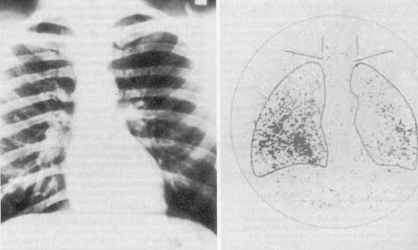
Figure 12. Despite the fact that the chest radiograph was read as normal, a total body scan using radioiodine demonstrated uptake in both lung fields, thus signifying the presence of unknown metastatic thyroid cancer. Note that the thyroid has been removed surgically because no uptake of isotope is present in the neck.
Finally, regardless of the operation, all patients with papillary or follicular cancer should be treated for life with levothyroxine therapy in sufficient doses to suppress TSH to the appropriate level. ³⁶ Care should be taken to not cause cardiac or other problems from thyrotoxicosis, however.

HÜRTHLE CELL TUMORS AND CANCER
Hürthle cell tumors are thought to be variants of follicular neoplasms, but others regard them as a totally separate disease entity. ^{38a} They are more difficult to treat than the usual follicular neoplasms, however, for several reasons:³⁸ (1) the incidence of carcinoma varies from 5.3% to 62% in different clinical series; (2) benign-appearing tumors later metastasize in up to 2.5% of patients; and (3) Hürthle cell cancers are far less likely to concentrate radioiodine than are the usual follicular carcinomas, which makes treatment of metastatic disease particularly difficult.
The difficulty in diagnosing Hurtle cell cancers and differentiating them from benign lesions is shown in the following study. Of 54 patients with Hürthle cell tumors whom we treated, ³⁸four had grossly malignant lesions. But during a mean follow-up period of 8.4 years, three additional Hürthle cell tumors were recognized as malignant after metastases were discovered. Thus, 7 of 54 (13%) of our patients who had a Hürthle cell tumor had Hürthle cell carcinoma. One of the 7 patients with Hürthle cell cancer died of widespread metastases after 35 years, and the other 6 were currently free of disease.
In a recent study, the size of the tumor was the major factor in determining whether or not a Hurthle cell neoplasm was malignant. ^{38b} Overall, 20% of the tumors were malignant, but those less than 2 cm were always benign. Tumors 4 cm or larger had a greater than 50% chance of malignancy, and all tumors greater than 6 cm were universally cancers. Finally, overexpression of Cyclin D1 and D3 may help predict malignant behavior in fine needle aspirates suspicious for malignant behavior. ^{38c}
We believe that treatment of these lesions should be individualized. ^{38,39} Total thyroid ablation is appropriate for frankly malignant Hürthle cell cancers, for all Hürthle cell tumors in patients who received low-dose childhood irradiation, for patients with associated papillary or follicular carcinomas, for all large tumors, certainly for those greater than 2 cm in diameter, and for patients whose tumors exhibit partial capsular invasion. On the other hand, single, well-encapsulated, benign-appearing Hürthle cell tumors that are small may be treated by lobectomy and careful follow-up because the chance that they will later exhibit malignant behavior is low (2.5% in our series and 1.5% among patients described in the literature). ³⁸ Nuclear DNA analysis may aid the surgeon in recognizing tumors that are potentially aggressive, because such tumors usually demonstrate aneuploidy. ⁴⁰ Furthermore, increased genetic abnormalities have been shown in Hürthle cell carcinomas when compared with Hürthle cell adenomas. ⁴¹
In a review of follicular cancers at the University of Chicago, ³⁹ the overall mortality rate was 16%, twice that of papillary carcinomas. However, in non–Hürthle cell follicular cancers the mortality was 12%, whereas in Hürthle cell cancers it was 24%, thus demonstrating the difficulty in treating metastatic disease which cannot be resected in the Hurthle group, because radioiodine therapy is almost always ineffective.These data are similar to those found in a recent large database study in which the overall death rate was approximately 18% for patients with Hurthle cell cancer and 11% for other well-differentiated thyroid cancers.^{41a}

ANAPLASTIC CARCINOMA
Anaplastic thyroid carcinoma remains one of the most aggressive of all cancers in humans. It makes up 1.3% to 9.8% of all thyroid cancers globally. ^{40a, 40b, 40c} The tumor grows very rapidly, and systemic symptoms are common. Survival for most patients is measured in months. Median survival was 5 to 6 months, and one year survival is approximately 20%. The previously so-called small cell type is now known to be a lymphoma and is most often treated by a combination of external radiation and chemotherapy. The large cell type may be manifested as a solitary thyroid nodule early in its clinical course. If it is operated on at that time, near-total or total thyroidectomy should be performed, with appropriate central and lateral neck dissection. However, anaplastic cancer is almost always advanced when the patient is first evaluated. Be sure to check vocal cord function preoperatively, for unilateral vocal cord paralysis is frequent.
With advanced disease, surgical cure is unlikely no matter how aggressively it is pursued. In particularly advanced cases, diagnosis by needle biopsy or by small open biopsy may be all that is appropriate. Sometimes the isthmus must be divided to relieve tracheal compression, or a tracheostomy might be beneficial. Most treatment, however, has been by external radiation therapy, chemotherapy, or both. Hyperfractionated external radiation therapy that uses several treatments per day has some enthusiasts, but complications may be high. ⁴² Radioiodine treatment is almost always ineffective because tumor uptake is absent. Although some success has been observed with doxorubicin, prolonged remissions are rarely achieved, and multidrug regimens, especially with Paclitaxel or Cisplatin, and combinations of chemotherapy with radiation therapy are being tried. ⁴³ Although remissions do occur, cures have rarely been achieved in advanced cases. New experimental drugs including monoclonal antibodies, kinase inhibitors, antiangiogenic drugs, and others are being tried because results of conventional therapy have been so dismal.^{40c} American thyroid Association guidelines for management of patients with anaplastic cancer including ethical considerations have recently been published.^{44a}

MEDULLARY THYROID CARCINOMA
Medullary thyroid carcinoma accounts for 5% to 8% of all thyroid cancers. It is a C-cell, calcitonin-producing tumor that contains amyloid or an amyloid-like substance. In addition to calcitonin, it may elaborate or secrete other peptides and amines such as carcinoembryonic antigen, serotonin, neurotensin, and a high-molecular-weight adrenocorticotropic hormone-like peptide. These substances may result in a carcinoid-like syndrome with diarrhea and Cushing’s syndrome, especially when widely metastatic tumor is present. Most medullary cancer of the thyroid is sporadic (about 70% to 80%), but it can also be transmitted in a familial pattern in 20% to 30% of cases. This tumor or its precursor, C-cell hyperplasia, occurs as a part of the multiple endocrine neoplasia type 2A (MEN2A) and type 2B (MEN2B) syndromes ⁴⁵ (Table 3; Figs. 13 and 14); or, rarely, as part of the familial medullary thyroid cancer syndrome. The MEN2 syndromes are transmitted as an autosomal-dominant trait, so 50% of the offspring would be expected to have this disease. Mutations of the RET oncogene on chromosome 10 have been found to be the cause of the MEN2 syndromes. ⁴⁶ These defects are germ-line mutations and can therefore be found in blood samples. All patients with medullary thyroid carcinoma should probably be screened for hyperparathyroidism and pheochromocytoma.⁴⁷ However, the risk of these two disease states accompanying the medullary cancer in MEN 2A is greatest in patients with a 630 or 634 RET mutation.^{50c} If a pheochromocytoma (or its precursor, adrenal medullary hyperplasia) is present, this should be operated on first because it has the greatest immediate risk to the patient. Family members, especially children, of a patient with medullary cancer of the thyroid should also be screened for medullary cancer of the thyroid if a patient has MEN2 with a RET oncogene mutation, but also if the tumor is bilateral or if C-cell hyperplasia is present. Genetic testing for RET mutations has largely replaced screening by calcitonin in family members. However, calcitonin and CEA measurements are still useful for screening patients with a thyroid mass when FNA analysis raises the possibility of medullary thyroid cancer.
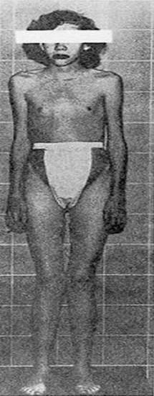
Figure 13. An 18-year-old female who demonstrates the appearance typically associated with multiple endocrine neoplasial type 2B (MEN2B) was found to have bilateral medullary carcinoma of the thyroid gland at surgery. The Marfan-like body habitus and facial features typically present in patients with MEN2B are clearly seen.
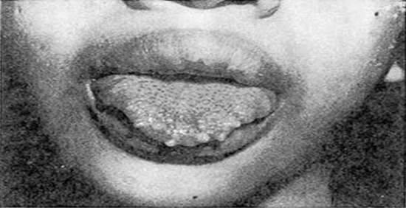
Figure 14. An 18-year-old female who demonstrates the appearance typically associated with multiple endocrine neoplasial type 2B (MEN2B) was found to have bilateral medullary carcinoma of the thyroid gland at surgery. Multiple neuromas of the tongue and lips are demonstrated. (Courtesy of Glen W. Sizemore.)
TABLE 3. Diseases Included in the MEN2 Syndromes
MEN2A | MEN2B
Medullary carcinoma | Medullary carcinoma
Pheochromocytoma | Pheochromocytoma
Hyperparathyroidism | - Hyperparathyroidism-unlikely  - Ganglioneuroma phenotype
MEN = Multiple endocrine neoplasia
Medullary cancer spreads to the lymph nodes of the neck and mediastinum, and later disseminates to the lungs, bone, liver, and elsewhere. The tumor is relatively radioresistant, does not take up radioiodine, and is not responsive to thyroid hormone suppression. Hence, an aggressive surgical approach is mandatory. The operation of choice for medullary cancer is total thyroidectomy coupled with aggressive resections of central and lateral lymph nodes, as well as mediastinal lymph nodes. ⁴⁶Careful and extensive modified radical neck dissections are required. Reoperations for metastatic tumor were rarely considered to be rewarding until the work of Tisell and Jansson. ⁴⁸ Their work, and that of others, ⁴⁹ demonstrated that 25% to 35% of patients with elevated circulating calcitonin levels could be rendered eucalcitoninemic after extensive, meticulous, reoperative neck dissection under magnification to remove all the tiny lymph nodes. In other patients, computed tomography (CT) and magnetic resonance imaging (MRI) have localized some sites of tumor recurrence, whereas octreotide and meta-iodobenzylguanidine scanning have sometimes been helpful. Recently, positron emission tomography combined with computerized tomography (PET-CT) have been successful in many patients. ^{49a} Laparoscopic evaluation of the liver is helpful before a reoperation since small metastatic lesions on its surface can sometimes be identified.
Cure is best in young children who are found by genetic screening to have a mutated RET oncogene. One hopes to operate on them when C-cell hyperplasia is present and before medullary cancer has started. ^{46a} Patients with MEN2A syndrome have a better prognosis than do those with sporadic tumor. ⁴⁵ Patients with MEN2B syndrome have the most aggressive tumors and rarely survive to middle age. Thus, in recent years, children 5 years of age or younger who are found by genetic screening to have MEN2A with a 634 RET mutation have received prophylactic total thyroidectomy to prevent the development of medullary cancer. In children with MEN2B screening for RET oncogene mutation should be done soon after birth, and with a mutated RET oncogene, total thyroidectomy should be done as early as possible within the first year of life in an experienced tertiary care setting. In MEN2B patients or infants and children older than one year, a prophylactic Level VI neck dissection should be considered as well.^{50c}In all of these infants and children, preservation of parathyroid function and recurrent nerve integrity is of the highest priority, because this cancer develops at a younger age than does MEN2A. ⁴⁹ With these prophylactic operations, cures are expected. Careful genetic counseling is highly recommended.
Long-term studies of medullary cancer from the Mayo Clinic group have shown that in patients without initial distant metastatic involvement and with complete resection of their medullary cancer, the 20-year survival rate, free of distant metastatic lesions, was 81%.⁵⁰ Overall 10- and 20-year survival rates were 63% and 44%, respectively. Thus, early diagnosis and complete initial resection of tumor are very important. A number of new therapies using tyrosine kinase inhibition are now being evaluated for metastatic disease. ^{50a} Screening and treatment for pheochromocytoma and hyperparathyroidism in children with MEN syndromes is discussed elsewhere.
Furthermore, an excellent review of medullary cancer has been written by Pacini and colleagues.^{50b}A very comprehensive set of guidelines for diagnosis, screening, surgical and medical treatment and followup of MEN2a and 2b, their pheochromocytomas and hyperparathyroidism as well as for sporadic medullary cancer has recently been published and is highly recommended.^{50c}

OPERATIVE TECHNIQUE FOR THYROIDECTOMY
While some groups have utilized local anesthesia with superficial cervical block, essentially all of our patients receive general anesthesia. The following description of thyroidectomy is used by one author (ELK). The patient is placed in a supine position with the neck extended. A low collar incision is made and carried down through the subcutaneous tissue and platysma muscle (Fig. 15A). Currently, small incisions are the rule unless a goiter is present. Superior and inferior subplatysmal flaps are developed, and the strap muscles are divided vertically in the midline and retracted laterally (Fig. 15B).
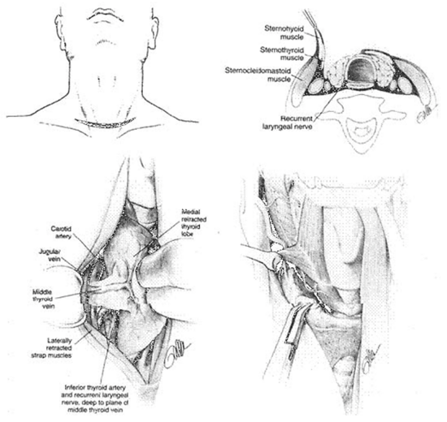
Figure 15. A, Incision for thyroidectomy. The neck is extended and a symmetrical, gently curved incision is made 1 to 2 cm above the clavicle. In recent years the author (ELK) has used a much smaller incision except when a large goiter is present. B, The sternohyoid and sternothyroid muscles are retracted to expose the surface of the thyroid lobe.C, The surgeon’s hand retracts the gland anteriorly and medially to expose the posterior surfaces of the thyroid gland. The middle thyroid vein is identified, ligated and divided. D, The superior thyroid vessels are ligated close to the thyroid capsule of the superior pole to avoid inadvertent injury to the external branch of the superior laryngeal nerve. This nerve can be seen in many cases.
The thyroid isthmus is often divided early in the course of the operation. The thyroid lobe is rotated medially. The middle thyroid vein is ligated (Fig. 15C). The superior pole of the thyroid is dissected free, and care is taken to identify and preserve the external branch of the superior laryngeal nerve (see Fig. 6). The superior pole vessels are ligated adjacent to the thyroid lobe, rather than cephalad to it, to prevent damage to this nerve (Fig. 15D). This nerve can be visualized in over 90% of patients if it is carefully dissected. ⁵¹ The inferior thyroid artery and recurrent laryngeal nerve are identified (Fig. 15E). To preserve blood supply to the parathyroid glands, the inferior thyroid artery should not be ligated laterally as a single trunk; rather, its branches should be ligated individually on the capsule of the lobe after they have supplied the parathyroid glands (Fig. 15F). The parathyroid glands are identified, and an attempt is made to leave each with an adequate blood supply while moving the gland off the thyroid lobe. Any parathyroid gland that appears to be devascularized can be placed in saline and later minced and implanted into the sternocleidomastoid muscle after a frozen section biopsy confirms that it is in fact a parathyroid gland. Care is taken to identify the recurrent laryngeal nerve and to gently follow along its course if a total lobectomy is to be done (Fig. 15G). The nerve is gently unroofed from surrounding tissue, with care taken to avoid trauma to it. The nerve is in greatest danger near the junction of the trachea with the larynx, where it is adjacent to the thyroid gland. Once the nerve and parathyroid glands have been identified and preserved, the thyroid lobe can be removed from its tracheal attachments by dividing the ligament of Berry (Fig. 15G). The contralateral thyroid lobe is removed in a similar manner when total thyroidectomy is performed. A near-total thyroidectomy means that a very small amount of thyroid tissue is left on the contralateral side to protect the parathyroid glands and recurrent nerve. Careful hemostasis and visualization of all important anatomic structures are mandatory for success. Some surgeons utilize the harmonic scalpel or electrothermal bipolar vessel sealing system and believe that they decrease the time of operation. However, one must be careful not to cause thermal damage. ^{51a}
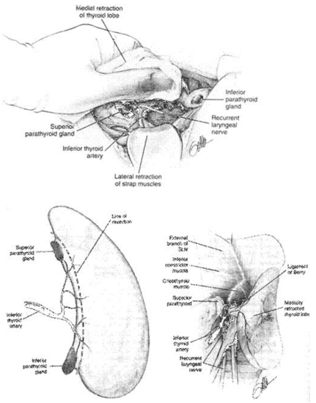
Figure 15. E , With careful retraction of the lobe medially, the inferior thyroid artery is placed under tension. This facilitates exposure of the recurrent laryngeal nerve and the parathyroid glands. F, The inferior thyroid artery is not ligated as a single trunk, but rather its tertiary branches are ligated and divided on the thyroid capsule. This preserves the blood supply to the parathyroid glands, which can be moved away from the thyroid lobe.G, The ligament of Berry is then ligated and divided and the thyroid lobe is removed. (Courtesy of Drs. Alan P. B. Dackiw and Orlo H. Clark.)
When closing, the author (ELK) does not tightly approximate the strap muscles in the midline; this allows drainage of blood superficially and thus prevents a hematoma in the closed deep space. Furthermore, ELK obtains better cosmesis by not approximating the platysmal muscle. Rather, the dermis is approximated by interrupted 4-0 sutures, and the epithelial edges are approximated with a running subcuticular 5-0 absorbable suture. Sterile paper tapes (Steri-strips) are then applied and left in place for approximately one to two weeks. When it is needed, a small suction catheter is inserted through a small stab wound; it is generally removed within 12 hours.

SUBTOTAL THYROIDECTOMY
Bilateral subtotal or near total lobectomy is the usual operation for Graves’ disease. An alternative operation, which is equally good, is lobectomy on one side and subtotal or near total lobectomy on the other side (Dunhill procedure). Once more, the parathyroid glands and recurrent nerves should be identified and preserved. Great care should be taken to not damage the recurrent laryngeal nerve when cutting across or suturing the thyroid lobe. At the end of the operation, 1 or 2 grams or less of thyroid tissue is usually left in place. The aim is to achieve an euthyroid state without a high recurrence of hyperthyroidism. When the operation is performed for severe ophthalmopathy, however, near-total or total thyroidectomy is performed.
After thyroidectomy, even if a modified neck dissection is done for carcinoma, the patient can almost always be safely discharged on the first postoperative day. Others are kept longer if the need arises. Some surgeons do not think that it is safe to discharge a patient on the day of surgery because of the risks of bleeding or hypocalcemia; however, same-day discharge is being practiced at some centers, usually after lobectomy. ⁵²

ALTERNATIVE TECHNIQUE OF THYROIDECTOMY
An alternative technique of thyroidectomy is practiced by some excellent surgeons ^{6,53} and is used by the authors in some operations. In this technique, the dissection is begun on the thyroid lobe and the parathyroids are moved laterally as described previously. However, the recurrent laryngeal nerve is not dissected along its length, but rather small bites of tissue are carefully divided along the thyroid capsule until the nerve is encountered near the ligament of Berry. Proponents of this technique feel that visualization of the recurrent laryngeal nerve by its early dissection may lead to greater nerve damage; however, most surgeons feel that seeing the nerve and knowing its pathway is safer and facilitates the dissection, in many instances.

MINIMALLY INVASIVE OPTIONS FOR THYROIDECTOMY
Over recent years, the development of ultrasonic shears and other electrothermal bipolar vessel sealing devices for hemostasis and small size endoscopes has allowed surgeons to perform thyroidectomies through much smaller incisions than using traditional techniques. Two different approaches have been taken to minimally invasive thyroidectomies. One technique, largely popularized in areas of the Far East such as Japan, China, and Korea, involves making incisions away from the neck in hidden areas such as in the axillae, chest, or the areola of the breast. The surgeon then creates a tunnel up to the neck where the thyroidectomy is performed with endoscopic instruments utilizing the endoscope for visualization. Approaches such as this are generally performed with low pressure insufflation and can completely avoid any incisions on the neck itself. Thus, the major advantage is a thyroidectomy without a neck scar. ⁵⁴⁻⁵⁷Most reports suggest significantly longer operative times, especially during a learning period. Perhaps most concerning to many American surgeons with these approaches is that if bleeding problems are encountered in the course of the thyroid dissection, a separate neck incision may need to be made to solve the problem. Additionally, recent reports have suggested the possibility that recurrent thyroid cancer can develop in the subcutaneous tunnel after the performance of an endoscopic thyroidectomy. ^{57a} Such complications will need to be carefully evaluated before wide acceptance of this technique can be recommended in cases of malignancy.
An alternative technique, developed by Dr. Paolo Miccoli and more widely utilized in Europe and to a less extent in the United States, utilizes a smaller incision than usual, but it is placed in the conventional location in the neck. ^{58,59} In general, a 1.5 to 2.0 cm incision is made in a conventional location in the neck and after the strap muscles are retracted from the thyroid gland, a 5 mm 30 degree endoscope is introduced into the incision. The scope is utilized to visualize the tissue along the lateral aspect of the thyroid gland and especially for the superior pole vessels. Usually after the superior and lateral aspects of the thyroid gland have been dissected free, the parathyroid glands and recurrent nerve are visualized and then the thyroid lobe is delivered through the neck incision and the remainder of the operation is performed in the conventional manner through the small cervical incision.
Several authors in the United States have reported good results in small series with this video-assisted approach. ^{60,61,61a} A significant benefit of this approach is that the incision is in the usual location so that if any bleeding results in difficulty with visualization during the procedure, the incision can be enlarged and a conventional thyroidectomy can readily be completed. Most authors have found this approach to be similar to conventional thyroidectomy in operative time, although the small neck incision does limit the size of the thyroid gland that could be resected utilizing this technique.
Recently Miccoli and his group have shown that minimally invasive video-assisted thyroidectomy and conventional thyroidectomy have the same rate of hypoparathyroidism and recurrent laryngeal nerve injury following operations for papillary thyroid cancer. ^{64a} Furthermore, no differences in outcome were noted at five years or in exposure to radioiodine therapy, suggesting the same degree of completeness of resection by both techniques. They believe that minimally invasive video-assisted thyroidectomy is a valid option to treat low and intermediate risk papillary thyroid cancer.
At this time in the United States, minimally invasive video-assisted thyroidectomy is offered in few specialized centers for selected patients with small thyroid nodules (usually less than 3 cm) and without evidence of thyroiditis. Except in the hands of surgeons very experienced in the technique, it should not be utilized for the treatment of most thyroid cancers. An excellent review of these minimally invasive techniques was written by Grogan and Duh.^{63a}

Robotic Transaxillary Thyroid Surgery
Using the da Vinci robot, several groups, largely from Korea, have developed a transaxillary approach to thyroidectomy. ^{64b,64c,64d} A 10 cm incision is made unilaterally or in both axillae and the dissection progresses from the axilla to the neck with performance of a lobectomy or total thyroidectomy. In malignant cases, a level 6 dissection can be performed as well. ^{64b} In their hands, robotic surgery can be performed with low complications, but the procedure takes longer than open surgery. There is a prolonged learning curve. Furthermore, use of the robot is expensive. The obvious advantage is cosmetic, since no scar is placed in the neck. In the United States this technique is in an earlier stage of development; however, more surgeons are utilizing this technique. ^{64e}Whether it proves to be a safe and effective procedure which can be practiced by many surgeons in a cost-effective manner or whether it is a “marketing tool” remains to be determined.

Transoral Thyroidectomy
Experiments have been done to determine whether or not it is possible and safe to perform a thyroidectomy through the floor of the mouth. ^{64f} Once more, the objective is to eliminate a scar in the neck.

POSTOPERATIVE COMPLICATIONS
Many authors have reported large series of thyroidectomies with no deaths. In other reports, mortality does not differ greatly from that from anesthesia alone. However, each patient should be evaluated for comorbidities, for it has been shown that elderly patients are more likely to suffer postoperative complications and longer hospitalizations than their younger counterparts following thyroidectomy.^{64G}Five major complications are associated with thyroid surgery: 1) thyroid storm, 2) wound hemorrhage, 3) wound infection, 4) recurrent laryngeal nerve injury, and 5) hypoparathyroidism.

Thyroid Storm
Thyroid storm reflects an exacerbation of a thyrotoxic state; it is seen most often in Graves’ disease, but it occurs less commonly in patients with toxic adenoma or toxic multinodular goiter. Clinical manifestations and management of thyroid storm are discussed elsewhere in this text.

Wound Hemorrhage
Wound hemorrhage with hematoma is an uncommon complication reported in 0.3% to 1.0% of patients in most large series. However, it is a well-recognized and potentially lethal complication.⁵² A small hematoma deep to the strap muscles can compress the trachea and cause respiratory distress. A small suction drain placed in the wound is not usually adequate for decompression, especially if bleeding occurs from an arterial vessel. Swelling of the neck and bulging of the wound can be quickly followed by respiratory impairment.
Wound hemorrhage with hematoma is an emergency situation, especially if any respiratory compromise is present. Treatment consists of immediately opening the wound and evacuating the clot, even at the bedside. Pressure should be applied with a sterile sponge and the patient returned to the operating room. Later, the bleeding vessel can be ligated in a careful and more leisurely manner under optimal sterile conditions with good lighting in the operating room. The urgency of treating this condition as soon as it is recognized cannot be overemphasized, especially if respiratory compromise is present.

Injury to the Recurrent Laryngeal Nerve
Injuries to the recurrent laryngeal nerve occur in 1% to 2% of thyroid operations when performed by experienced neck surgeons, and at a higher prevalence when thyroidectomy is done by a less experienced surgeon. They occur more commonly when thyroidectomy is done for malignant disease, especially if a total thyroidectomy is done. Sometimes the nerve is purposely sacrificed if it runs into an aggressive thyroid cancer. Nerve injuries can be unilateral or bilateral and temporary or permanent, and they can be deliberate or accidental. Loss of function can be caused by transection, ligation, clamping, traction, or handling of the nerve. Tumor invasion can also involve the nerve. Occasionally, vocal cord impairment occurs as a result of pressure from the balloon of an endotracheal tube as the recurrent nerve enters the larynx. In unilateral recurrent nerve injuries, the voice becomes husky because the vocal cords do not approximate one another. Shortness of breath and aspiration of liquids sometimes occur as well. Most nerve injuries are temporary and vocal cord function returns within several months; it certainly returns within 9 to 12 months if it is to return at all. If no function returns by that time, the voice can be improved by operative means. The choice is insertion of a piece of Silastic to move the paralyzed cord to the midline; this procedure is called a laryngoplasty. Early in the course of management of a patient with hoarseness or aspiration, the affected vocal cord can be injected with various substances to move it to the midline and to alleviate or improve these symptoms.
Bilateral recurrent laryngeal nerve damage is much more serious, because both vocal cords may assume a medial or paramedian position and cause airway obstruction and difficulty with respiratory toilet. Most often, tracheostomy is required. In the authors’ experience, permanent injuries to the recurrent laryngeal nerve are best avoided by identifying and carefully tracing the path of the recurrent nerve. Accidental transection occurs most often at the level of the upper two tracheal rings, where the nerve closely approximates the thyroid lobe in the area of Berry’s ligament. If recognized, many believe that the transected nerve should be reapproximated by microsurgical techniques, although this is controversial. A number of procedures to later reinnervate the laryngeal muscles have been performed with improvement in unilateral nerve injuries, but with only limited success when a bilateral nerve injury has occurred.⁶⁵
Injury to the external branch of the superior laryngeal nerve may occur when the upper pole vessels are divided (Fig. 6) if the nerve is not visualized.⁹ This injury results in impairment of function of the ipsilateral cricothyroid muscle, a fine tuner of the vocal cord. This injury causes an inability to forcefully project one’s voice or to sing high notes because of loss of function of the cricothyroid muscle. Often, this disability improves during the first few months after surgery.

Recurrent Laryngeal Nerve Monitoring
In recent years many surgeons have sought to try to further diminish the low incidence of recurrent laryngeal nerve (RLN) injury by use of nerve monitoring devices during surgery. Although several devices have been utilized, all have in common some means of detecting vocal cord movement when the RLN is stimulated. Many small series have been reported in the literature assessing the potential benefits of monitoring to decrease the incidence of nerve injury. ^{65a, 65b} Given the low incidence of RLN injury, it is not surprising that no study has shown a statistically significant decrease in RLN injury when using a nerve monitor. The largest series in the literature by Dralle reported on a multi-institutional German study of 29,998 nerves at risk in thyroidectomy. ^{65c} Even with a study this large, no statistically significant decrease in rates of RLN injury could be shown with nerve monitoring.
Among the problems of nerve monitoring technology are that the devices can malfunction,often because of endotracheal tube misplacement, so that the surgeon cannot depend on the device to always identify the nerve. Proponents of nerve monitoring suggest that the technology is helpful even if a statistically significant decrease in the rate of RLN cannot be shown.
Goretzki and his group, for example, have published data that when operating upon bilateral benign thyroid disease, if nerve monitoring suggests a nerve injury on the first side, they have modified or restricted the resection of the contralateral thyroid lobe. ^{65d} In this way, they have decreased or eliminated the incidence of bilateral RLN injuries. This is very important.
Although some authors have suggested that RLN monitors may be most helpful in difficult reoperative cases when significant scar tissue is encountered, this has not been shown to be the case and many authors have advocated routine use. ^{67a} Nerve monitoring technology in thyroid surgery should never take the place of meticulous dissection. Surgeons may choose to use the technology, but the data do not support the suggestion that nerve monitors allow thyroid surgery to be performed in a safer fashion than that by a good surgeon utilizing careful technique. An excellent international guide to the use of electrophysiologic RLN monitoring during thyroid and parathyroid surgery has recently been published.^{65f}Furthermore, a review of the medical, legal, and ethical aspects of RLN monitoring has been written by Angelos. ^{65e}

HYPOPARATHYROIDISM
Postoperative hypoparathyroidism can be temporary or permanent. The incidence of permanent hypoparathyroidism has been reported to be as high as 20% when total thyroidectomy and radical neck dissection are performed, and as low as 0.9% for subtotal thyroidectomy. Other excellent neck surgeons have reported a lower incidence of permanent hypoparathyroidism, even about one percent following total thyroidectomy. ⁶⁶ Postoperative hypoparathyroidism is rarely the result of inadvertent removal of all of the parathyroid glands but is more commonly caused by disruption of their delicate blood supply. Devascularization can be minimized during thyroid lobectomy by dissecting close to the thyroid capsule, by carefully ligating the branches of the inferior thyroid artery on the thyroid capsule distal to their supply of the parathyroid glands (rather than ligating the inferior thyroid artery as a single trunk), and by treating the parathyroids with great care. If a parathyroid gland is recognized to be ischemic or nonviable during surgery, it can be autotransplanted often after identification by frozen section. The gland is minced into 1 to 2mm cubes and placed into a pocket(s) in the sternocleidomastoid muscle.
Postoperative hypoparathyroidism results in hypocalcemia and hyperphosphatemia; it is manifested by circumoral numbness, tingling of the fingers and toes, and intense anxiety occurring soon after surgery. Chvostek’s sign appears early, and carpopedal spasm can occur. Symptoms develop in most patients when the serum calcium level is less than 7.5 to 8 mg/dL. Parathyroid hormone is low or absent in hyopoparathyroidism.
We measure the serum calcium and parathyroid hormone levels approximately 12 hours after operation and frequently thereafter. Most patients are able to leave the hospital on the morning after surgery if they are asymptomatic and their serum calcium level is 7.8 mg/dL or above. Oral calcium pills are used liberally. Patients with severe symptomatic hypocalcemia are treated in the hospital with 1 g (10 mL) of 10% calcium gluconate infused intravenously over several minutes. Then, if necessary, 5 g of this calcium solution is placed in each 500mL intravenous bottle to run continuously, starting with approximately 30 mL/hour. Oral calcium, usually as calcium carbonate (1250 mg to 2500 mg four times per day), should be started. Each 1250 mg pill of calcium carbonate contains 500 mg of calcium. With this treatment regimen most patients become asymptomatic. The intravenous therapy is tapered and stopped as soon as possible, and the patient is sent home and told to take oral calcium pills. This condition is referred to as transient or temporary hypocalcemia or transient hypoparathyroidism. Serum calcium, phosphorus, and parathyroid hormone determinations are helpful.
Management of persistent severe hypocalcemia requires the addition of a vitamin D preparation to facilitate the absorption of oral calcium. We prefer the use of 1,25-dihydroxyvitamin D (Calcitriol) because it is the active metabolite of vitamin D and has a more rapid action than regular vitamin D. Calcitriol 0.5 mcg with oral calcium carbonate therapy is given four times daily for the first several days, then this priming dose of vitamin D is reduced. The usual maintenance dose for most patients with permanent hypoparathyroidism is Calcitriol 0.25 to 0.5 mcg once daily, along with calcium carbonate, 500 mg Ca ²⁺ once or twice daily, although some patients require larger doses. Serum calcium levels must be monitored carefully after discharge, and the dosage of the medications is adjusted promptly to prevent hypercalcemia as well as hypocalcemia. Finally, the serum parathyroid hormone level should be analyzed periodically to determine whether permanent hypoparathyroidism is truly present, because the authors and others have seen cases of postoperative tetany, perhaps caused by “bone hunger,” that later resolved completely. In such cases, circulating parathyroid hormone is normal and all therapy can be stopped. Remember that in bone hunger, both the serum calcium and phosphorus values are low, whereas in hypoparathyroidism, the serum calcium value is low but the phosphorus level is elevated. Permanent hypoparathyroidism is usually not diagnosed until at least six months have passed and parathyroid hormone remains low or absent.
McHenry has shown that the incidence of complications following thyroidectomy varies greatly. ^{66a} In general, those surgeons with excellent training and a large experience with this operation have lesser complications, particularly following cancer procedures and reoperative surgery.

DEVELOPMENTAL ABNORMALITIES OF THE THYROID
To understand the different thyroid anomalies, it is important to briefly review normal development of this gland. The thyroid is embryologically an offshoot of the primitive alimentary tract, from which it later becomes separated ^{67–70} (Figs. 16 and 17). During the third to fourth week in utero, a median anlage of epithelium arises from the pharyngeal floor in the region of the foramen cecum of the tongue (i.e., at the junction of the anterior two thirds and the posterior third of the tongue). The main body of the thyroid, referred to as the median lobe or median thyroid component, follows the descent of the heart and great vessels and moves caudally into the neck from this origin. It divides into an isthmus and two lobes, and by 7 weeks it forms a “shield” over the front of the trachea and thyroid cartilage. It is joined by a pair of lateral thyroid lobes originating from the fourth and fifth branchial pouches (Fig. 17). From these lateral thyroid components, now commonly called the ultimobranchial bodies, C cells (parafollicular cells) enter the thyroid lobes. C cells contain and secrete calcitonin and are the cells that give rise to medullary carcinoma of the thyroid gland. Williams and associates have described cystic structures in the neck near the upper parathyroid glands in cases in which thyroid tissue was totally lingual in location. ⁷¹ These cysts contained both cells staining for calcitonin and others staining for thyroglobulin. This study, they believe, offers evidence that the ultimobranchial body contributes both C cells and follicular cells to the thyroid gland of humans.
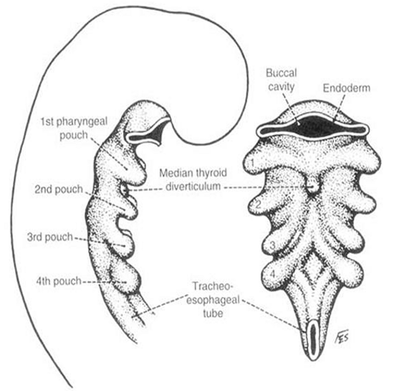
Figure 16. Early embryologic development of the pharyngeal anlage in a 4mm embryo. Note the beginning of thyroid development in the median thyroid diverticulum. (From Sedgwick CE, Cady B: Surgery of the Thyroid and Parathyroid Glands, 2d ed. Philadelphia, WB Saunders, 1980, p 7; adapted from Weller GL: Development of the thyroid, parathyroid and thymus glands in man. Contrib Embryol Carnegie Inst Wash 24:93–142, 1933.)
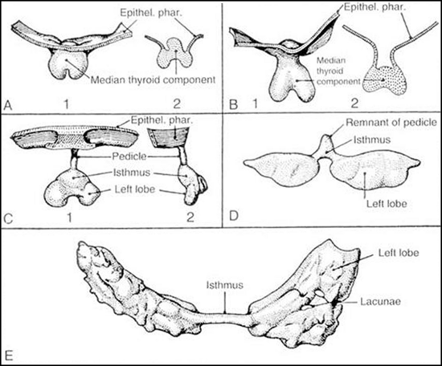
Figure 17. Stages in the development of the thyroid gland. A, 1, Thyroid primordium and pharyngeal epithelium of a 4.5mm human embryo; 2, section through the same structure showing a raised central portion. B, 1, Thyroid primordium of a 6.5mm embryo; 2, section through the same structure. C, 1, Thyroid primordium of an 8.2mm embryo beginning to descend; 2, lateral view of the same structure. D, Thyroid primordium of an 11mm embryo. The connection with the pharynx is broken, and the lobes are beginning to grow laterad. E, Thyroid gland of a 13.5mm embryo. The lobes are thin sheets curving around the carotid arteries. Several lacunae, which are not to be confused with follicles, are present in the sheets. (From Weller GL: Development of the thyroid, parathyroid and thymus glands in man. Contrib Embryol Carnegie Inst Wash 24:93–142, 1933.)
As the gland moves downward, it leaves behind a trace of epithelial cells known as the thyroglossal tract. From this structure both thyroglossal duct cysts and the pyramidal lobe of the thyroid develop. The mature thyroid gland may take on many different configurations depending on the embryologic development of the thyroid and its descent (Fig. 18).
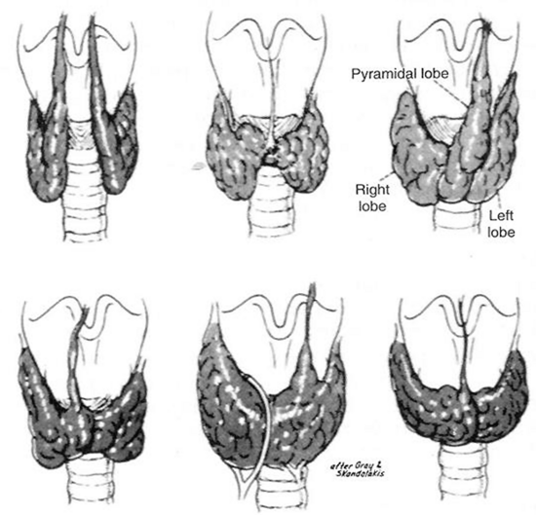
Figure 18. Variations of normal adult thyroid anatomy resulting from embryologic descent and division of the thyroid gland. (From Sedgwick CE, Cady B: Surgery of the Thyroid and Parathyroid Glands, 2d ed. Philadelphia, WB Saunders, 1980; adapted from Gray SW, Skandalakis JE: Embryology for Surgeons. Philadelphia, WB Saunders, 1972.)

THYROID ABNORMALITIES
The median thyroid anlage may, on rare occasions, fail to develop. The resultant athyrosis, or absence of the thyroid gland, is associated with cretinism. The anlage also may differentiate in locations other than the isthmus and lateral lobes. The most common developmental abnormality, if looked on as such, is the pyramidal lobe (Fig. 18), which has been reported to be present in as many as 80% of patients in whom the gland was surgically exposed. Usually, the pyramidal lobe is small; however, in Graves’ disease or in lymphocytic thyroiditis, it is often enlarged and is commonly clinically palpable. The pyramidal lobe generally lies in the midline but can arise from either lobe. Origin from the left lobe is more common than is origin from the right lobe. ⁷²

THYROID HEMIAGENESIS
More than 100 cases have been reported in which only one lobe of the thyroid is present. ⁷³ The left lobe is absent in 80% of these patients. Often, the thyroid lobe that is present is enlarged, and both hyperthyroidism and hypothyroidism have been reported at times. Females are affected three times as often as males. Both benign and malignant nodules have been reported in this condition. ⁷⁴
Other variations involving the median thyroid anlage represent an arrest in the usual descent of part or all of the thyroid-forming material along the normal pathway. Ectopic thyroid development can result in a lingual thyroid or in thyroid tissue in a suprahyoid, infrahyoid, or intratracheal location. Persistence of the thyroglossal duct as a sinus tract or as a cyst (called a thyroglossal duct cyst) is the most common of the clinically important anomalies of thyroid development (Fig. 20). Finally, the entire gland or part of it may descend more caudally; this results in thyroid tissue located in the superior mediastinum behind the sternum, adjacent to the aortic arch or between the aorta and pulmonary trunk, within the upper portion of the pericardium, and even within the interventricular septum of the heart. Most intrathoracic goiters, however, are not true anomalies, but rather are extensions of pathologic elements of a normally situated gland into the anterior or posterior mediastinum. Each of these abnormalities is discussed in greater depth.

ECTOPIC THYROID
Lingual Thyroid
A lingual thyroid is relatively rare and is estimated to occur in 1 in 3000 cases of thyroid disease. However, it represents the most common location for functioning ectopic thyroid tissue. Lingual thyroid tissue is associated with an absence of the normal cervical thyroid in 70% of cases. It occurs much more commonly in women than in men.
The diagnosis is usually made by the discovery of an incidental mass on the back of the tongue in an asymptomatic patient (Fig. 19). The mass may enlarge and cause dysphagia, dysphonia, dyspnea, or a sensation of choking. ⁷⁵ Hypothyroidism is often present and may cause the mass to enlarge and become symptomatic, but hyperthyroidism is very unusual. In women, symptomatic lingual thyroid glands develop during puberty or early adulthood in most cases. Buckman, in his review of 140 cases of symptomatic lingual thyroids in females, reported that 30% occurred in puberty, 55% between the ages of 18 and 40 years, 10% at menopause, and 5% in old age. ⁷⁶ He attributed this distribution to hormonal disturbances, which are more apparent in female subjects during puberty and may be precipitated by pregnancy. The incidence of malignancy in lingual thyroid glands is low. ⁷⁷ The diagnosis of a lingual thyroid should be suspected when a mass is detected in the region of the foramen cecum of the tongue, and it is definitively established by radioisotope scanning (see Fig. 19).
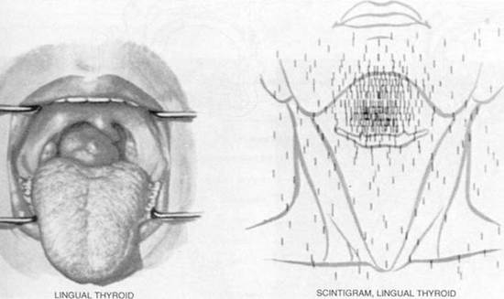
Figure 19. Left , The appearance of a large lingual thyroid. Right , A radioiodine scan demonstrating all activity to be above the hyoid bone, with no evidence of the presence of normally placed thyroid issue. (From Netter RA: Endocrine system and selected metabolic diseases. In Ciba Collection of Medical Illustrations. Summit, NJ, Ciba-Geigy, 1974, p 45.)
The usual treatment of this condition is thyroid hormone therapy to suppress the lingual thyroid and reduce its size. Only rarely is surgical excision necessary. Indications for extirpation include failure of suppressive therapy to reduce the size, ulceration, hemorrhage, and suspicion of malignancy. ⁷⁸ Autotransplantation of thyroid tissue has been tried on rare occasions when no other thyroid tissue is present, and it has apparently been successful. A lingual thyroid was reported in two brothers, which suggests that this condition may be inherited. ⁷⁹

Suprahyoid and Infrahyoid Thyroid
In these cases, thyroid tissue is present in a midline position above or below the hyoid bone. Hypothyroidism with elevation of thyrotropin (TSH) secretion is commonly present because of the absence of a normal thyroid gland in most instances. An enlarging mass commonly occurs during infancy, childhood, or later life. Often, this mass is mistaken for a thyroglossal duct cyst, because it is usually located in the same anatomic position. ⁸⁰ If it is removed, all thyroid tissue may be ablated, a consequence that has definite physiologic as well as possible medicolegal implications. To prevent total thyroid ablation, it is recommended that an ultrasound examination be performed in all cases of thyroglossal duct cyst before its removal to be certain that a normal thyroid gland is present. Furthermore, before removing what appears to be a thyroglossal duct cyst, a prudent surgeon should be certain that no solid areas are present. If any doubt exists, the normal thyroid gland should be explored and palpated. Finally, if ectopic thyroid tissue rather than a thyroglossal duct cyst is encountered at surgery in an infant, its blood supply should be preserved; the ectopic gland divided vertically; and each half translocated laterally, deep to the strap muscles, where it is no longer manifested as a mass. If normal thyroid tissue is demonstrated to be present elsewhere or in the adult, it may be better to remove the ectopic tissue rather than transplant it, because carcinoma arising from these developmental abnormalities, although rare, has been reported.

THYROGLOSSAL DUCT CYSTS
Both cysts and fistulas can develop along the course of the thyroglossal duct ⁸¹ (Fig. 20). These cysts are the most common anomaly in thyroid development seen in clinical practice. ⁸² Normally, the thyroglossal duct becomes obliterated early in embryonic life, but occasionally it persists as a cyst. Such lesions occur equally in males and females. They are seen at birth in about 25% of cases; most appear in early childhood; and the rest, about one third, become apparent only after age 30 years. ⁸³ Cysts usually appear in the midline or just off the midline between the isthmus of the thyroid and the hyoid bone. They commonly become repeatedly infected and may rupture spontaneously. When this complication occurs, a sinus tract or fistula persists. Removal of a thyroglossal cyst or fistula requires excision of the central part of the hyoid bone and dissection of the thyroglossal tract to the base of the tongue (the Sistrunk procedure) if recurrence is to be minimized. This procedure is necessary because the thyroglossal duct is intimately associated with the central part of the hyoid bone (Fig. 21). Recurrent cysts are very common if this operative procedure is not followed.
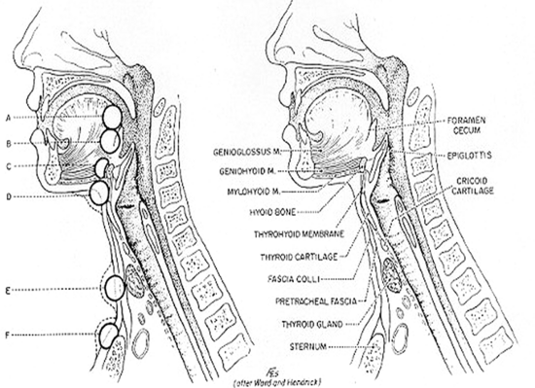
Figure 20. Location of thyroglossal cysts: (A) in front of the foramen cecum; (B) at the foramen cecum; (C) suprahyoid; (D) infrahyoid; (E) area of the thyroid gland; (F) suprasternal. (From Sedgwick CE, Cady B: Surgery of the Thyroid and Parathyroid Glands, 2nd ed. Philadelphia, WB Saunders, 1980.)
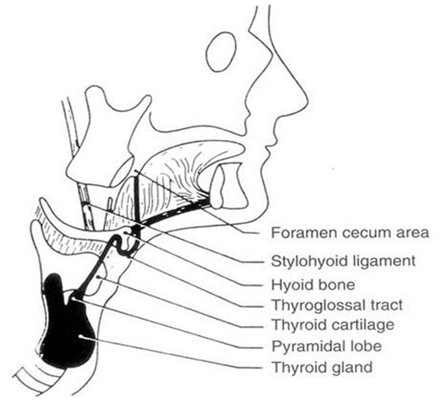
Figure 21. Diagram of the course of the thyroglossal tract. Note its proximity to the hyoid bone. (From Allard RHB: The thyroglossal cyst. Head Neck Surg 5:134–146, 1982.)
At least 115 cases of thyroid carcinoma have been reported to originate from the thyroglossal duct. ⁸² Often, in such cases an association is noted with low-dose external irradiation of the head and neck in infancy or childhood. Almost all carcinomas have been papillary, and their prognosis is excellent. If a carcinoma is recognized, at the time of surgery the thyroid gland should be inspected for evidence of other tumor nodules, and the lateral lymph nodes should be sampled. Our practice and that of many others is to perform near-total or total thyroidectomy with appropriate nodal resection when a thyroglossal duct carcinoma is found and resected. In one series of 35 patients with papillary carcinoma arising in a thyroglossal duct cyst, the thyroid gland of 4 patients (11.4%) also contained papillary cancer. ⁸² This operative procedure permits later radioiodine therapy as well.
In addition to papillary cancer, approximately 5% of all carcinomas arising from a thyroglossal duct cyst are squamous; rare cases of Hürthle cell and anaplastic cancer have also been reported. Finally, three families have been reported in which a total of 11 members had a thyroglossal duct cyst. ⁸⁴

LATERAL ABERRANT THYROID
Small amounts of histologically normal thyroid tissue are occasionally found separate from the thyroid. If these tissue elements are near the thyroid, not in lymph nodes, and entirely normal histologically, it is possible that they represent developmental abnormalities. True lateral aberrant thyroid tissue or embryonic rests of thyroid tissue in the lymph nodes of the lateral neck region are very rare. Most agree that the overwhelming number of cases of what in the past was called “lateral aberrant thyroid” actually represented well-differentiated thyroid cancer metastatic to a cervical lymph node rather than an embryonic rest. In such cases, we favor near-total or total thyroidectomy with a modified radical neck dissection on the side of the lymph node, possibly followed by radioiodine therapy.
Several lateral thyroid masses have been reported that are said to be benign adenomas in lateral ectopic sites. ^{85,86} The authors of these studies suggest that they may develop ectopically because of failure of fusion of the lateral thyroid component with the median thyroid. However, before accepting this explanation, it is important to be certain that each of these lesions does not represent a well-differentiated metastasis that has totally replaced a lymph node and in which the primary thyroid carcinoma is small or even microscopic and was not recognized.

SUBSTERNAL GOITERS
Developmental abnormalities may lead to the finding of thyroid tissue in the mediastinum or, rarely, even within the tracheal or esophageal wall. However, most substernal goiters undoubtedly originate in the neck and then “fall” or are “swallowed” into the mediastinum and are not embryologically determined at all.
Substernal goiters have been reported to occur in 0.1% to 21% of patients in whom thyroidectomies were performed. This large variability is undoubtedly caused partly by a difference in classification among the authors, but it may also be caused by the incidence of endemic goiter. More recent series report an incidence of 2% or less. ⁸⁷
Many substernal goiters are found on routine chest radiography in patients who are completely asymptomatic. Other patients may have dyspnea or dysphagia from tracheal or esophageal compression or displacement. Superior vena caval obstruction can occasionally occur with edema and cyanosis of the face, ⁸⁸ and venous engorgement of the arms and face (Fig. 22). Most individuals with substernal goiters are euthyroid or hypothyroid; however, hyperthyroidism occurs as well. Although the goiters of Graves’ disease are rarely intrathoracic, single or multiple “hot” nodules may occur within an intrathoracic goiter and result in hyperthyroidism as part of a toxic nodular goiter.
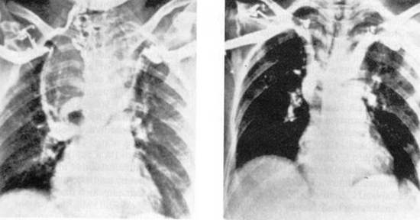
Figure 22. Large substernal goiter resulting in superior vena caval syndrome. Left , A venogram demonstrated complete obstruction of the superior vena cava, displacement of the innominate veins, and marked collateral circulation. Right , Three weeks after thyroidectomy, patency of the vena cava was restored. Some displacement of the innominate veins remained at that time. (From Lesavoy MA, Norberg HP, Kaplan EL: Substernal goiter with superior vena caval obstruction. Surgery 77:325–329, 1975.)
Intrathoracic goiters are usually found in the anterior mediastinum and, less commonly, in the posterior mediastinum. In either instance the diagnosis is suggested if a goiter can be palpated in the neck and if it appears to continue below the sternum. Rarely, however, no thyroid enlargement in the cervical area is present, and instead of being in continuity, the intrathoracic component may be attached to the cervical thyroid only by a narrow bridge of thyroid or fibrous tissue. The diagnosis of an intrathoracic thyroid mass can be made by the use of a thyroid isotope scan; however, CT or MRI are usually more helpful.
Regarding therapy, we generally agree with the recommendation made by Lahey and Swinton more than 50 years ago that goiters that are definitely intrathoracic should usually be removed if the patient is a good operative risk. ⁸⁹ Because of the cone-shaped anatomy of the upper thoracic outlet, once part of a thyroid goiter has passed into the superior mediastinum, it can increase its size only by descending further into the chest. Thus, delay in surgical management may lead to increased size of the lesion, a greater degree of symptoms, and perhaps a more difficult or hazardous operative procedure.
Substernal goiters should be operated on initially through a cervical incision, because the blood supply to the substernal thyroid almost always originates in the neck and can be readily controlled in this area. Only rarely does an intrathoracic goiter receive its blood supply from mediastinal vessels; however, such a finding favors a developmental cause. Thus, in most instances, good hemostasis can be obtained by control of the superior and inferior thyroid arteries in the neck. Thus, most substernal goiters can be removed through the neck.
The authors like to divide the isthmus and the upper pole vessels early in the dissection. The affected thyroid lobe is then carefully dissected along its capsule by blunt dissection into the superior mediastinum. While gentle traction is exerted from above, the mass is elevated by the surgeon’s fingers or blunt, curved clamps (Fig. 23). Often these maneuvers suffice to permit extraction of a mass from the mediastinum and into the neck area. Any fluid-filled cysts may be aspirated to reduce the size of the mass and permit its egress through the thoracic outlet. Piecemeal morcellation of the thyroid gland should not be practiced, because this occasionally has led to severe bleeding. Furthermore, rarely a substernal goiter has been found to contain carcinoma, and this technique violates all principles of cancer surgery.
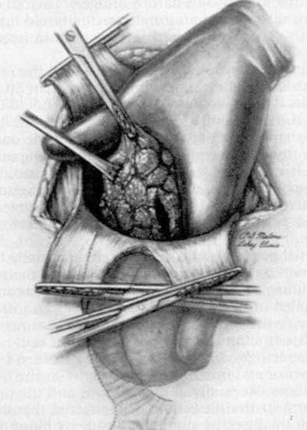
Figure 23. Finger dissection of a substernal goiter. Note that the index finger is inserted into the mediastinum outside the thyroid capsule and is swept around until the gland is freed from the pleura and other tissue in the mediastinum. Occasionally, despite traction, a substernal goiter does not pass out through the superior thoracic outlet because of its size. In such cases, it may be necessary to evacuate some of the colloid material from within the goiter. Then, with gentle upward traction on the capsule, the mass can be elevated into the neck wound and resected. Occasionally a partial sternotomy is necessary. (From Sedgwick CE, Cady B: Surgery of the Thyroid and Parathyroid Glands, 2nd ed. Philadelphia, WB Saunders, 1980.)
With the use of this method, the great majority of substernal thyroid glands can be removed transcervically. If the thyroid gland cannot be easily extracted from the mediastinum, however, a partial or complete sternotomy should be performed. This procedure affords direct control of any mediastinal vessels and permits resection of the thyroid gland to be carried out safely.
As in all thyroid surgery, the recurrent laryngeal nerves must be preserved and treated with care. The parathyroid glands should be identified and preserved, and the inferior thyroid artery’s branches should be ligated close to the thyroid capsule to prevent ischemia of the parathyroid glands, which might result in hypoparathyroidism.

STRUMA OVARII
Ectopic development of thyroid tissue far from the neck area can also lead to difficulties in rare instances. Dermoid cysts or teratomas, which are uncommon ovarian germ cell tumors, occur in female subjects of all age groups. About 3% can be classified as an ovarian struma, because they contain functionally significant thyroid tissue or thyroid tissue occupying more than 50% of the volume of the tumor. Many more such tumors contain small amounts of thyroid tissue. Some strumae ovarii are associated with carcinoid-appearing tissue. These strumal-carcinoid tumors secrete or contain thyroid hormones as well as somatostatin, chromogranin, serotonin, glucagon, insulin, gastrin, or calcitonin. ⁹⁰ Some are associated with carcinoid syndromes.
Struma ovarii is sometimes manifested as an abdominal mass lesion, often with peritoneal or pleural effusion that may be bloody. Most of these lesions synthesize and iodinate thyroglobulin poorly, and thus, despite growth of the mass, thyrotoxicosis does not develop. However, perhaps one fourth to one third of ovarian strumae are associated with thyrotoxicosis. ^{91,92} Many of these lesions may be contributing to autoimmune hyperthyroidism in response to a common stimulator such as thyroid-stimulating immunoglobulins. In other instances, the struma alone is clearly responsible for the thyrotoxicity. An elevated free thyroxine index or free T4, a suppressed TSH value, and uptake of radioiodine in a mass in the pelvis are the obvious prerequisites for making the diagnosis. ⁹³ Often, in ovarian struma, symptoms and findings of thyrotoxicosis are present in patients who have low uptake of radioiodine in their thyroid glands. Thus, a “high index of suspicion” is most important. Usually, operative resection of an ovarian tumor is indicated. After surgery, transient postoperative hypothyroidism and “thyroid storm” have occasionally been reported.
Benign thyroid adenomas in strumae are common, and about 5% manifest evidence of carcinoma. ⁹⁴ Usually, these lesions are resectable, but external radiation therapy and/or ¹³¹ I ablation has been advised after resection of the malignant tumors to avoid the tendency for late recurrence or metastatic disease, which has sometimes been fatal. Metastatic disease occurs in approximately 5% of these malignant tumors. It is best treated with ¹³¹ I therapy. TSH should be suppressed with thyroxine as is done for thyroid cancer originating in the usual location.

STRUMA CORDIS
Functioning, apparently normal intracardiac thyroid tissue has been reported a few times and has been visualized by radioiodine imaging. ⁹⁵ The clinical finding is usually a right ventricular mass, and the diagnosis has typically been made after operative removal.
REFERENCES
1. Halsted WS: The operative story of goitre. Johns Hopkins Hosp Rep 19:71, 1920.
2. Thompson NW: The history of hyperparathyroidism. Acta Chir Scand 156:5–21, 1990.
3. Kocher T: Uber Kropfextirpation und ihre Folgen. Arch Klin Chirurgie 29:254, 1883.
4. Kaplan EL, Kadowaki MH, Schark C: Routine exposure of the recurrent laryngeal nerve is important during thyroidectomy. In Simmons RL, Udekwu AO (eds): Debates in Clinical Surgery, vol 1. Chicago, Year Book, 1990, pp 191–206.
5. Henry JF, Audriffe J, Denizot A, et al: The non-recurrent inferior laryngeal nerve: Review of 33 cases including 2 on the left side. Surgery 104:977–984, 1988.
6. Thompson NW, Demers M: Exposure is not necessary to avoid the recurrent laryngeal nerve during thyroid operations. In Simmons RL, Udekwu AO (eds): Debates in Clinical Surgery, vol 1. Chicago, Year Book, 1990, pp 207–219.
7. Moosman DA, DeWeese JS: The external laryngeal nerve as related to thyroidectomy. Surg Gynecol Obstet 127:1011, 1968.
8. Cernea CR, Ferraz AR, Nishio S, et al: Surgical anatomy of the external branch of the superior layrngeal nerve. Head Neck 14:380–383, 1992.
9. Lennquist S, Cahlin C, Smeds S: The superior laryngeal nerve in thyroid surgery. Surgery 102:999, 1987.
9a. Friedman M, LoSavio P, Ibrahim H: Superior laryngeal nerve identification and preservation during surgery. Arch Otolaryngol Head Neck Surg 128(3):296-303, 2002.
10. Kaplan EL, Sugimoto J, Yang H, Fredland A: Postoperative hypoparathyroidism: Diagnosis and management. In Kaplan EL (ed): Surgery of the Thyroid and Parathyroid Glands. New York, Churchill Livingstone, 1983, pp 262–274.
11. Gilmour JR: The embryology of the parathyroid glands, the thymus and certain associated rudiments. J Pathol 45:507, 1937.
12. Taylor S: Surgery of the thyroid gland. In DeGroot LJ, Stanbury JB: The Thyroid and its Diseases, 4th ed. New York, John Wiley & Sons, 1975, pp 776–779.
12a. Grodski S, Cornford L, Sywak M, Sidhu S, Delbridge L: Routine level VI lymph node dissection for papillary thyroid cancer: Surgical technique. ANZ J Surg 77(4):203-208, 2007.
13. Ezzat S, Sarti DA, Cain DR, Braunstein GD: Thyroid incidentalomas. Prevalence by palpation and ultrasonography. Arch Intern Med 154:1838–1840, 1994.
14. DeGroot LJ: Clinical features and management of radiation-associated thyroid carcinoma. In Kaplan EL (ed): Surgery of the Thyroid and Parathyroid Glands. Edinburgh, Churchill Livingstone, 1983, p 940.
15. Kaplan EL: An operative approach to the irradiated thyroid gland with possible carcinoma: Criteria technique and results. In DeGroot LJ, Frohman LA, Kaplan EL, Refetoff S (eds): Radiation Associated Carcinoma of the Thyroid. New York, Grune & Stratton, 1977, p 371.
15a. Kaplan EL, Mhoon D, Kaplan S, Angelos P: Radiation-induced thyroid cancer: The Chicago experience. Surgery 146(6):979-985, 2009.
15b. Sinnott B, Ron E, Schneider AB: Exposing the thyroid to radiation: A review of its current extent, risks and implications. Endocr Rev 210(5):756-773, 2010.
16. Naunheim KS, Kaplan EL, Straus FH II, et al: High dose external radiation to the neck and subsequent thyroid carcinoma. In Kaplan EL (ed): Surgery of the Thyroid and Parathyroid Glands. New York, Churchill Livingstone, 1983, pp 51–62.
17. Shafford EA, Kingston JE, Healy JC, et al: Thyroid nodular disease after radiotherapy to the neck for childhood Hodgkin’s disease. Br J Cancer 80:808–814, 1999.
18. Ron E: Thyroid cancer incidence among people living in areas contaminated by radiation from the Chernobyl accident. Health Physics 93(5):502-511, 2007.
19. Nikiforov YE: Radiation-induced thyroid cancer: What have we learned from Chernobyl. Endocr Pathol 17(4):307-317, 2006.
19a. Collins BJ, Schneider AB, Prinz RA, Xu X: Low frequency of BRAF mutations in adult patients with papillary thyroid cancers following childhood radiation exposure. Thyroid 16(1):61-66, 2006.
19b. Tronko M, Bogdanova T, Voskoboynyk L, et al: Radiation induced thyroid cancer: Fundamental and applied aspects. Exp Oncol 32(3):200-204, 2010.
20. Shibru D, Chung K-W, Kebebew E: Recent developments in the clinical application of thyroid cancer biomarkers. Curr Opinion Oncol 20(1):13-18, 2008.
20a. Cibas ES, Ali SZ: The Bethesda System for reporting thyroid cytology. Thyroid 19:1159-1165, 2009.
21. Xing M: BRAF mutation in papillary thyroid cancer: Pathogenic role, molecular bases, and clinical implications. Endocr Rev 28(7):742-762, 2007.
21a. Cooper DS, Doherty GM, Hangen BR, et al: Revised American Thyroid Association management guidelines for patients with thyroid nodules and differentiated thyroid cancer. Thyroid 19:1167-1214, 2009.
21b. Alexander AK, Kennedy GC, Baloch ZW, et al: Preoperative diagnosis of benign thyroid nodules with indeterminate cytology. N Engl J Med 367(8):705-715, 2012.
22. Becker C: Hypothyroidism and atherosclerotic heart disease: Pathogenesis, medical management, and the role of coronary artery bypass surgery. Endocr Rev 6:432, 1985.
23. Klementschitsch P, Shen K-L, Kaplan EL: Reemergence of thyroidectomy as treatment for Graves’ disease. Surg Clin North Am 59:35, 1979.
24. Lennquist S, Jortso E, Anderberg B, Smeds S: Beta-blockers compared with antithyroid drugs as preoperative treatment of hyperthyroidism: Drug tolerance, complications and postoperative thyroid function. Surgery 98:1141, 1985.
25. Sridama V, Reilly M, Kaplan EL, et al: Long-term follow up study of compensated low dose ¹³¹ I therapy for Graves’ disease. N Engl J Med 311:426, 1984.
26a. Clark OH: Total thyroidectomy: The treatment of choice for patients with differentiated thyroid cancer. Ann Surg 196:361–370, 1982.
26b. Cobin RH, Gharib H, Bergman DA, et al: AACE/AAES medical/surgical guidelines for clinical practice: Management of thyroid cancer. Endocr Pract 7:203-220, 2001.
26c. Thyroid Cancer Treatment (PDQ^{R}) National Cancer Institute 2012. www.cancergov/cancertopics/pdq/treatment/thyroid.
27. Attie JN: Modified neck dissection in treatment of thyroid cancer: A safe procedure. Eur J Cancer Clin Oncol 2:315–324, 1988.
27a. McKenzie TJ, Lillegard JB, Grant CS, Hay ID, Fisher JE, Doherty GM, Thompson GB: Is prophylactic central compartment lymph node dissection necessary for papillary thyroid carcinoma? World J Endocr Surg 2(1):1-7, 2010.
27b. Sywak M, Cornford L, Roach P, et al: Routine ipsilateral level VI lymphadenectomyreduces postop thyroglobulin levels in papillary thyroid cancer. Surgery 140:1000-1005, 2006.
27c. Henry JF, Gramatica L, Dentzot A, et al: Morbidity of prophylactic lymph node dissection in the central neck area in patients with papillary thyroid carcinoma. Arch Surg 338:167-169, 1998.
27d. Monchik JM, Simon CJ, Caragacianu DL, Thomay AA, Tsai V, Cohen J, Mazzaglia PJ: Does failure to perform prophylactic level VI node dissection leave persistent disease detectable by ultrasonography in patients with low-risk papillary carcinoma of the thyroid? Surgery 146(6):1182-1187, 2009.
28. Beierwaltes WH: Treatment of metastatic thyroid cancer with radioiodine and external radiation therapy. In Kaplan EL (ed): Surgery of the Thyroid and Parathyroid Glands, Clinical Surgery International, vol 4. Edinburgh, Churchill Livingstone, 1983, p 103.
28a. Pacini F, Ladenson PW, Schlumberger M, et al: Radioiodine ablation of thyroid remnants after preparation with recombinant human thyrotropin in differentiated thyroid carcinoma. J Clin Endocrinol 91:926-932, 2006.
29. Hay ID, Grant CS, Taylor WF, et al: Ipsilateral lobectomy versus bilateral lobar resection in papillary thyroid carcinoma: A retrospective analysis of surgical outcome using a novel prognostic scoring system. Surgery 102:1088, 1988.
30. Cady B, Rossi R: An expanded view of risk-group definition in differentiated thyroid carcinoma. Surgery 104:947, 1988.
31. Hay ID, Bergstralh EJ, Goellner JR, et al: Predicting outcome in papillary thyroid carcinoma: Development of a reliable scoring system in a cohort of 1779 patients surgically treated at one institution during 1940 through 1989. Surgery 114:1050–1058, 1993.
32. Hay ID, Grant CS, Bergstralh MS, et al: Unilateral lobectomy: Is it sufficient surgical treatment for patients with AMES low-risk papillary thyroid carcinoma? Surgery 124:958–964, 1998.
33. Grant CS, Hay ID, Gough IR, et al: Local recurrence in papillary thyroid carcinoma. Is extent of surgical resection important? Surgery 104:954–962, 1988.
34. DeGroot LJ, Kaplan EL, McCormick M, Straus FH II: Natural history, treatment and course of papillary thyroid carcinoma. J Clin Endocrinol Metab 71:414–424, 1990.
35. DeGroot LJ, Kaplan EL, Straus FH II, Shukla MS: Does the method of management of papillary thyroid carcinoma make a difference in outcome? World J Surg 18:123–130, 1994.
36. Mazzaferri EL, Jhiang SM: Long-term impact of initial surgical and medical therapy on papillary and follicular thyroid cancer. Am J Med 97:418–428, 1994.
36a. Grogan RH, Kaplan SP, Cao H, et al: 27 Year followup of 269 thyroid cancer patients. In press.
37. van Heerden JA, Hay ID, Goellner JR, et al: Follicular thyroid carcinoma with capsular invasion alone: A non-threatening malignancy. Surgery 112:1130–1136, 1992.
38. Arganini M, Behar R, Wu FL, et al: Hürthle cell tumors: A twenty-five year experience. Surgery 100:1108, 1986.
38a. Mills SC, Haq M, Smellie WJB, Harmer C: Hurthle cell carcinoma of the thyroid: Retrospective review of 62 patients treated at the Royal Marsden Hospital between 1946 and 2003. Eur J Surg Oncol 35(3):230-234, 2009.
38b. Sippel RS, Elaraj DM, Khanafshar E, Zarnegar R, Kebebew E, Duh QY, Clark OH: Tumor size predicts malignant potential in Hurthle cell neoplasms of the thyroid. World J Surg 32:702-707, 2008.
38c. Troncone G, Volante M, Iaccarino A, Zeppa P, Cozzolino I, Malapelle U, Palmieri EA, Conzo G, Papotti M, Palombini L: Cyclin D1 and D3 overexpression predicts malignant behavior in thyroid fine-needle aspirates suspicious for Hurthle cell neoplasms. Cancer Cytopathol 117(6):522-529, 2009.
39. DeGroot LJ, Kaplan EL, McCormick M, Straus FH II: Morbidity and mortality in follicular thyroid cancer. J Clin Endocrinol Metab 80:2946–2952, 1995.
40. Schark C, Fulton N, Yashiro T, et al: The value of measurement of ras oncogenes and nuclear DNA analysis in the diagnosis of Hürthle cell tumors of the thyroid. World J Surg 16:745–752, 1992.
40a. Smallridge RC: Anaplastic thyroid carcinoma: Pathogenesis and emerging therapies. Clin Oncol (in press).
40b. Are C, Shaha AR: Anaplastic thyroid carcinoma: Biology, pathogenesis, prognostic factors, and treatment approaches. Ann Surg Oncol 13(4):453-464, 2006.
40c. Catalano MG, Poli R, Pugliese M, Fortunati N, Boccuzzi G: Emerging molecualr therapies of advanced thyroid cancer. Molecular Aspects of Med 31(2):215-226, 2010.
41. Segev DL, Saji M, Phillips GS, et al: Polymerase chain reaction-based microsatellite polymorphism analysis of follicular and Hurthle cell neoplasms of the thyroid. J Clin Endocrinol Metab 83:2036–2042, 1998.
41a. Goffredo P, Roman SA, Sosa JA: Hurthle cell carcinoma: A population level analysis of 3311 patients. Cancer, August 14, 2012 (Epub ahead of print).
42. Mitchell G, Huddart R, Harmer C: Phase II evaluation of high dose accelerated radiotherapy for anaplastic thyroid carcinoma. Radiother Oncol 50:33–38, 1999.
43. Agiris A, Agarwala SS, Karamouzis MV, Burmeister LA, Carty SE: A phase II trial of doxorubicin and interferon alpha 2b in advanced, non-medullary thyroid cancer. Investigation New Drugs 26(2):183-188, 2008.
44. Antonelli A, Ferrari SM, Fallahi P, Berti P, Materazzi G, Barani L, Marchetti I, Ferrannini E, Miccoli P: Primary cell cultures from anaplastic thyroid cancer obtained by fine-needle aspiration used for chemosensitivity tests. Clin Endocrin 69(1):148-152, 2008.
44a. Smallridge RC, Ain KB, Asa SL, et al: American Thyroid Association guidelines for management of patients with anaplastic thyroid cancer. Thyroid 22(11):1104-1139, 2012.
45. Sizemore GW, van Heerden JA, Carney JA: Medullary carcinoma of the thyroid gland and the multiple endocrine neoplasia type 2 syndrome. In Kaplan EL (ed): Surgery of the Thyroid and Parathyroid Glands, Clinical Surgery International, vol 4, Edinburgh, Churchill Livingstone, 1983, p 75.
46. Hofstra RM, Landsvater RM, Ceccherini I, et al: A mutation in the RET proto oncogene associated with multiple endocrine neoplasia type 2B and sporadic medullary thyroid carcinoma. Nature 367:375–376, 1994.
46a. Machens A, Niccoli-Sire P, Hoegel J, et al: Early malignant progression of hereditary medullary thyroid cancer. New Eng J Med 349:1517-1525, 2003.
47. Goretzki PE, Hoppner W, Dotzenrath C, et al: Genetic and biochemical screening for endocrine disease. World J Surg 22:1202–1207, 1998.
48. Tisell LE, Jansson S: Recent results of reoperative surgery in medullary carcinoma of the thyroid. Wien Klin Wochenschr 100:347–348, 1988.
49. Skinner MA, DeBenedetti MK, Moley JF, et al: Medullary thyroid carcinoma in children with multiple endocrine neoplasia types 2A and 2B. J Pediatr Surg 31:177–181, 1996.
49a. Iagaru A, Kalinyak JE, McDougall Ir: F-18 FDG PET/CT in the management of thyroid cancer. Clin Nucl Med 32(9):690-695, 2007.
50. Gharib H, McConahey WM, Tiego RD, et al: Medullary thyroid carcinoma: Clinicopathologic features and long term follow up of 65 patients treated during 1946 through 1970. Mayo Clin Proc 67:934–940, 1992.
50a. Ball DW: Medullary thyroid cancer: therapeutic targets and molecular markers. Curr Opinion in Oncol 19(1):18-23, 2007.
50b. Pacini F, Castagna MG, Cipri C, Schlumberger M: Medullary thyroid carcinoma. Clin Oncol (R Coll Radiol) 6:475-485, 2010.
50c. Kloos RT, Eng C, Evans DB, et al: Medullary thyroid cancer: Management guidelines of the American Thyroid Association. Thyroid 19(11):1295, 2009.
51. Aina EN, Hisham A: The external laryngeal nerve in thyroid surgery: recognition and implication. ANZ J Surg 71:212–214, 2001.
52. Schwartz AE, Clark O, Ituarte P, LoGerfo P: Therapeutic controversy. Thyroid surgery: The choice. J Clin Endocrinol Metab 83:1097–1105, 1998.
53. Delbridge L: Total thyroidectomy: The evolution of surgical technique. ANZ J Surg 73(9):761–768, 2003.
54. Chung YS, Choe JH, Kang KH, et al: Endoscopic thyroidectomy for thyroid malignancies: comparison with conventional open thyroidectomy. World J Surg 31:2302-2306, 2007.
55. Miccoli P, Berti P, Raffaelli M, et al: Minimally invasive video-assisted thyroidectomy. Am J Surg 181:567–570, 2001.
56. Ferzli G, Sayad P, Abdo Z, Cacchione R: Minimally invasive, nonendoscopic thyroid surgery. J Am Coll Surg 192:665–668, 2001.
57. Park CS, Chung WY, Chang HS: Minimally invasive open thyroidectomy. Surg Today 31:665–669, 2001.
57a. Kim JH, Choi YJ, Kim JA, et al: Thyroid cancer that developed around the operative bed and subcutaneous tunnel after endoscopic thyroidectomy via a breast approach. Surg Laparosc, Endosc & Percutaneous Tech 18:197-201, 2008.
58. Miccoli P, Elisei R, Materazzi G, et al: Minimally invasive video-assisted thyroidectomy for papillary carcinoma: A prospective study of its completeness. Surgery 132:1070–1074, 2002.
59. Duh QY: Recent advances in minimally invasive endocrine surgery. Asian J Surg 26:62–63, 2003.
60. Ikeda Y, Takami H, Sasaki Y, et al: Comparative study of thyroidectomies. Endoscopic surgery vs. conventional open surgery. Surg Endosc 16:1741–1745, 2002.
61. Ng JWT: Minimally invasive thyroid surgery: Where are we now? ANZ J Surg 73:769–770, 2003.
61a. Terris DJ, Angelos P, Steward DL, et al: Minimally invasive video-assisted thyroidectomy: A multi-institutional North American experience. Arch Otolaryngol, Head and Neck Surg 134(1):81-84, 2008.
62. Yeung GHC, Wong HWY: Videoscopic thyroidectomy: The uncertain path to practicality. Asian J Surg 26:133–138, 2003.
63. Delbridge L: Minimally invasive parathyroidectomy: The Australian experience. Asian J Surg 26:76–81, 2003.
63a. Grogan RH and Duh Q-Y: Conventional thyroidectomy versus MIT: An outcome analysis. In: Minimally Invasive Thyroidectomy. D Linos and Wy Chung (eds). Springer Verlag Berlin Heidelberg, pp 247-251, 2012.
64. Brunaud L, Zarnegar R, Wada N, et al: Incision length for standard thyroidectomy and parathyroidectomy. When is it minimally invasive? Arch Surg 138:1140–1143, 2003.
64a. Pinchera MP, Materazzi G, Biagini A, Berti P, Faviana P, Molinaro E, Viola D, Elisei R: Surgical treatment of low- and intermediate-risk papillary thyroid cancer with minimally invasive video-assisted thyroidectomy. J Clin Endocrinol Metab 94(5):1618-1622, 2009.
64b. Kang SW, Lee SC, Lee SH, Lee KY, Jeong JJ, Lee YS, Nam KH, Chang HS, Chung WY, Park CS: Robotic thyroid surgery using a gasless, transaxillary approach and the da Vinci S system: The operative outcomes of 338 consecutive patients. Surgery 146(6): 1048-1055, 2009.
64c. Lee J, Nah KY, Kim RM, Ahn YH, Soh EY, Chung WY: Differences in postoperative outcomes, function, and cosmesis: open versus robotic thyroidectomy. Surg Endosc 2010 (in press).
64d. Youn YK: Selection criteria for the oncoplastic thyroid surgery used in Seoul National University Hospital. Surg Laparosc, Endosc & Percutaneous Techniques 19(6):518-519, 2009.
64e. Holsinger FC, Sweeney AD, Jantharapattana K, Salem A, Weber RS, Chung WY, Lewis CM, Grant DG: The emergence of endoscopic head and neck surgery. Curr Oncol News 12(3):216-222, 2010.
64f. Miccoli P, Materazzi G, Berti P: Natural orifice surgery on the thyroid gland using totally transoral video-assisted thyroidectomy: report of the first experimental results for a new surgical method: are we going in the right direction? Surg Endosc 24(4):957-958, 2009.
64g. Grogan RH, Mitmaker EJ, Hwang J, et al: A population-based prospective cohort study of complications after thyroidectomy in the elderly. J Clin Endocrinol Metab 97(5):1645-1653, 2012.
65. Miyauchi A, Matsusaka K, Kihara M, et al: The role of ansa to recurrent laryngeal nerve anastomosis in operations for thyroid cancer. Eur J Surg 164:927–933, 1998.
65a. Donnellan KA, Pitman KT, Cannon CR, Replogle WH, Simmons JD: Intraoperative laryngeal nerve monitoring during thyroidectomy. Arch Otolaryngol Head & Neck Surg 135(12):1196-1198, 2009.
65b. Atallah I, Dupret A, Carpentier AS, Weingertner AS, Volkmar PP, Rodier JF: Role of intraoperative neuromonitoring of the recurrent laryngeal nerve in high-risk thyroid surgery. J Otolaryngol Head & Neck Surg 38(6): 613-618, 2009.
65c. Dralle H, Sekulla C, Lorenz K, et al: Intraoperative monitoring of the recurrent laryngeal nerve in thyroid surgery. World J Surg 32:1358-1366, 2008.
65d. Goretzki PE, Schwarz K, Brinkmann J, Wirowski D, Lammers BJ: The impact of intraoperative neuromonitoring (IONM) on surgical strategy in bilateral thyroid diseases: Is it worth the effort? World J Surg 34:1274-1284, 2010.
65e. Angelos P: Recurrent laryngeal nerve monitoring: State of the art, ethical and legal issues. Surg Clin N Amer 89(5):1157-1169, 2009.
65f. Randolph GW, Dralle H, with the International Intraoperative Monitoring Study Group, Abdullah H, et al: Electrophysiologic recurrent laryngeal monitoring during thyroid and parathyroid surgery: International standards guideline statement. Laryngoscope 121:S1-S16, 2011.
66. Pattou F, Combemale F, Fabre S, et al: Hypocalcemia following thyroid surgery: Incidence and prediction of outcome. World J Surg 22:718–724, 1998.
66a. McHenry CR: Patient volumes and complications in thyroid surgery. Brit J Surg 89(7):821-823, 2002.
67. Sedgwick CE, Cady B: Surgery of the Thyroid and Parathyroid Glands, 2d ed. Philadelphia, WB Saunders, 1980.
68. Weller GL: Development of the thyroid, parathyroid and thymus glands in man. Contrib Embryol Carnegie Inst Wash 24:93–142, 1933.
69. Gray SW, Skandalakis JE: Embryology for Surgeons. Philadelphia, WB Saunders, 1972.
70. Norris EH: Parathyroid glands and lateral thyroid in man: Their morphogenesis, histogenesis, topographic anatomy and prenatal growth. Contrib Embryol Carnegie Inst Wash 26:247–294, 1937.
71. Williams ED, Toyn CE, Harach HR: The ultimobranchial gland and congenital thyroid abnormalities in man. J Pathol 159:135–141, 1989.
72. Siraj QH, Aleem N, Inam-Ur-Rehman A, et al: The pyramidal lobe: A scintigraphic assessment. Nucl Med Commun 10:685–693, 1989.
73. Vasquez-Chavez C, Acevedo-Rivera K, Sartorius C, Espinosa-Said L: Thyroid hemiagenesis: Report of 3 cases and review of the literature. Gac Med Mex 125:395–399, 1989.
74. Khatri VP, Espinosa MH, Harada WA: Papillary adenocarcinoma in thyroid hemiagenesis. Head Neck 14:312–315, 1992.
75. Netter RA: Endocrine system and selected metabolic diseases. In Ciba Collection of Medical Illustrations. Summit, NJ, Ciba Pharmaceutical Company, 1974, p 45.
76. Buckman LT: Lingual thyroid. Laryngoscope 46:765–784, 878–897, 935–955, 1936.
77. Zink A, Rave F, Hoffmann R, Ziegler R: Papillary carcinoma in ectopic thyroid. Horm Res 35:86–88, 1991.
78. Elprana D, Manni JJ, Smals AGH: Lingual thyroid. ORL J Otorhinolaryngol Relat Spec 46:147–152, 1984.
79. Defoer FY, Mahler C: Lingual thyroid in two natural brothers. J Endocrinol Invest 13:65–67, 1990.
80. Conklin WT, Davis RM, Dabb RW, Reilly CM: Hypothyroidism following removal of a “thyroglossal duct cyst.” Plast Reconstr Surg 68:930–932, 1981.
81. Allard RHB: The thyroglossal cyst. Head Neck 5:134–146, 1982.
82. Weiss SD, Orlich CC: Primary papillary carcinoma of a thyroglossal duct cyst: Report of a case and review of the literature. Br J Surg 78:87–89, 1991.
83. Katz AD, Hachigian M: Thyroglossal duct cysts: A thirty-year experience with emphasis on occurrence in older patients. Am J Surg 155:741–744, 1988.
84. Issa MM, de Vries P: Familial occurrence of thyroglossal duct cyst. J Pediatr Surg 26:30–31, 1991.
85. Zieren J, Paul M, Scharfenberg M, Menenakos C: Submandibular ectopic thyroid gland. J Craniofacial Surg 17(6):1194-1198, 2006.
86. Stanton A, Allen-Mersh TG: Is laterally situated ectopic thyroid tissue always malignant? J R Soc Med 77:333–334, 1984.
87. Wychulis AR, Payne WS, Clagett OT, et al: Surgical treatment of mediastinal tumors. J Thorac Cardiovasc Surg 62:379, 1971.
88. Lesavoy MA, Norberg HP, Kaplan EL: Substernal goiter with superior vena caval obstruction. Surgery 77:325–329, 1975.
89. Lahey FH, Swinton NW: Intrathoracic goiter. Surg Gynecol Obstet 59:627, 1934.
90. Stagno PA, Petras RE, Hart WR: Strumal carcinoids of the ovary: An immunohistologic and ultrastructural study. Arch Pathol Lab Med 111:440–446, 1987.
91. Ramagopal E, Stanbury JB: Studies of the distribution of iodine and protein in a struma ovarii. J Clin Endocrinol Metab 25:526, 1965.
92. Kempers RD, Dockerty MB, Hoffman DL, Bartholomew LG: Struma ovarii-ascitic, hyperthyroid, and asymptomatic syndromes. Ann Intern Med 72:883, 1970.
93. March DE, Desai AG, Park CH, et al: Struma ovarii: Hyperthyroidism in a postmenopausal woman. J Nucl Med 29:263–265, 1988.
94. Thomas RD, Batty VB: Metastatic malignant struma ovarii: Two case reports. Clin Nucl Med 17:577–578, 1992.
95. Rieser GD, Ober KP, Cowan RJ, Cordell AR: Radioiodide imaging of struma cordis. Clin Nucl Med 13:421, 1988.

